PRESSURE
- (a) Define the term pressure and state its S.I unit.
(b) (i) Explain why a tractor can easily move in muddy areas than the bicycle.
(ii) Explain why one feels more pain when pinched with a needle than a nail.
(c) State the assumption of pressure made in liquids.

(d) A force of 20N is exerted on an object of cross sectional area 2m². Calculate the pressure exerted on the object.

- A force of 50N is exerted on a ball of cross sectional area 4m². Calculate the pressure.

- The pressure exerted on an object of 5cm² is 100Nm⁻². Calculate the force exerted on the object.
c) A box measures 5m by 2m by 1m and has a weight of 40N. Calculate
(i) Minimum pressure.
(ii) Maximum pressure.

(d)
1m
2m
3m
If the force exerted on a box is 24N. Calculate
- Minimum pressure.
(ii) Maximum pressure.
- Explain why it is easier to cut meat with a sharp knife than with a blunt edge.

- A boy tries to pop a balloon using his finger (a) and then with a needle (b).
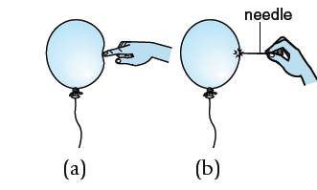

Find the pressure exerted on the balloon if he presses the balloon with a force of 1.8 N using,
- his finger; assuming the area of the fingertips 1.2×10⁻⁴ m²,

- a needle; assuming the area of the needle tip s 2.4×10⁻⁷ m².

(iii) What conclusion can be draw from answers of (a)(i) and (ii).

(b) Show that the pressure in liquids is given by $pressure=ρhg$.
(i) State the factors affecting pressure in liquids.
ii) The figure below shows a rectangular block of mass 3.0 kg.
0.006 m²

0.02 m²

Calculate the maximum pressure the block can exert on the ground.

Explain why an elephant walks over mud easily than a goat.
(c)(i)
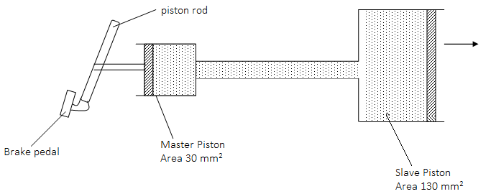
The diagram above shows a hydraulic braking system. When a force of 700N is applied to the master piston, find the force which will be exerted on the slave piston
- State any other two applications of the same principle.

- (i) Define the term atmospheric pressure.
- State any four applications of atmospheric pressure.

- Calculate the weight B, lifted by the H.P of piston area 48cm² with a force of 20N whose piston area is 400cm² as shown below
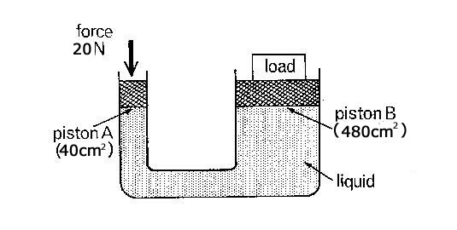
- A diver under water uses breathing apparatus at a depth where the pressure
is 1.25 × 10⁵Pa.

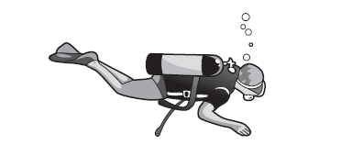

A bubble of gas breathed out by the diver has a volume of 20cm³ when it is released. The bubble moves upwards to the surface of the water . At the surface of the water, the atmospheric pressure is 1.00 × 10⁵Pa. The temperature of the water is the same at all depths. What is the volume of this bubble when it reaches the surface?

(b) (i) Describe an experiment to show that pressure in liquids increases with increase in depth.
(ii) Describe an experiment to show that pressure is independent of the cross sectional area.
iii)Describe an experiment to show that pressure is equally transmitted through out the liquid.

- State Pascal’s principle or law of liquid pressure.
(b) State the assumption of Pascal’s principle.

- (a) Outline the applications of Pascal’s principle.
(d) Calculate the weight, W, raised by a force of 40N applied on a small piston area of 10m² and the large piston having area of 20m².
An hydraulic machine shown in Figure 3 below has an efficiency of 98.0%. What effort would be required to lift a load of 20,000N?

LOAD
20,000N
40cm
10cm
Area = 20cm²
Area = 100cm²

- A force of 100N applied on a piston of area 5m² is used to lift a load, W, with a large piston area of 25m². Calculate the value of W.

- (a) Describe an experiment to demonstrate the existence of pressure using a crushing can.
(b) Name the pressure the air exerts on the earth’s surface.
(c) Name the instrument used to measure atmospheric pressure.
(d) The atmospheric pressure at a place is 75cmHg. Change this pressure into Nm⁻² given that the density of mercury is 13600 kgm⁻³. \
(e) With the aid of a diagram explain how a simple barometer can be used to measure atmospheric pressure.

(f) The figure below shows two columns A, if the density of the liquid is 130g/cm³.find the value of h
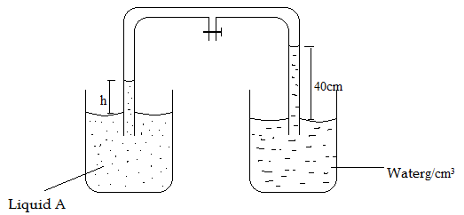

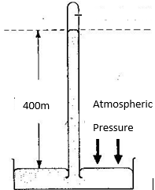
Calculate the atmospheric pressure
- incmHg.
- Pascal or Nm⁻²
(e) Given that the atmospheric pressure of mercury is 76cmHg and the density of mercury 13600kgm⁻³. Calculate the atmospheric pressure in Nm⁻² or Pascal.
(f) (i) The column of mercury supported by the atmospheric pressure is 76cm. Find the column of water supported by atmospheric pressure in the same place.
- Explain why water is not used in a barometer using the answer in (i).
- (a) Outline the applications of atmospheric pressure.
(b) Explain briefly how a person is able to drink using a straw.
(c) With the aid of a diagram, explain the mode of operation of lift pump or common pump.
(d) With the aid of a diagram, explain the mode of operation of a force pump.
With the aid of a diagram, explain how a bicycle pump works.

- (a) With the aid of a diagram, explain how a monometer can be used to measure the fluid pressure.
(b)

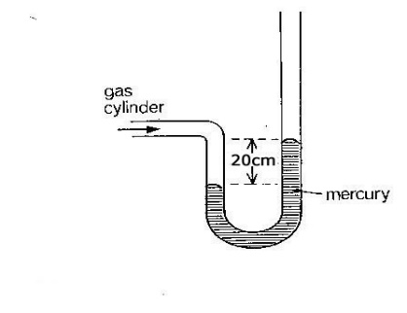

Find the gas pressure if the atmospheric pressure H = 76cmHg and density of mercury 13600kgm⁻³
- in cmHg

(ii) in Nm⁻²
(c)
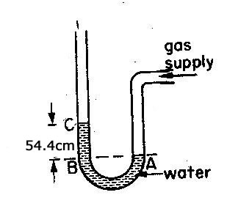
If the density of water is 1000kgm⁻³ and H = 76cmHg. Calculate pressure in Nm⁻².

- (a) Describe an experiment to demonstrate how monometer can be used in comparison or
comparing density of two liquids.

(b)Figure shows a tank containing mercury and water. Find the pressure exerted by the two liquids on the bottom of the tank.
Water
Mercury
3m
2m

(Density of water
= 1.0 x 10³kgm^{–3},
Density of mercury
= 1.36 x 10⁴kgm^{–3})

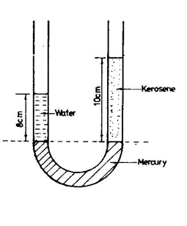
If the density of water is 1000kgm⁻³. Calculate;
- The density of kerosene.
- The relative density of kerosene.
(c)
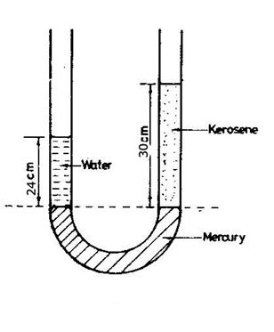
If the density of water is 1000kgm⁻³ calculate
- The density of kerosene.
- Relative density of kerosene.

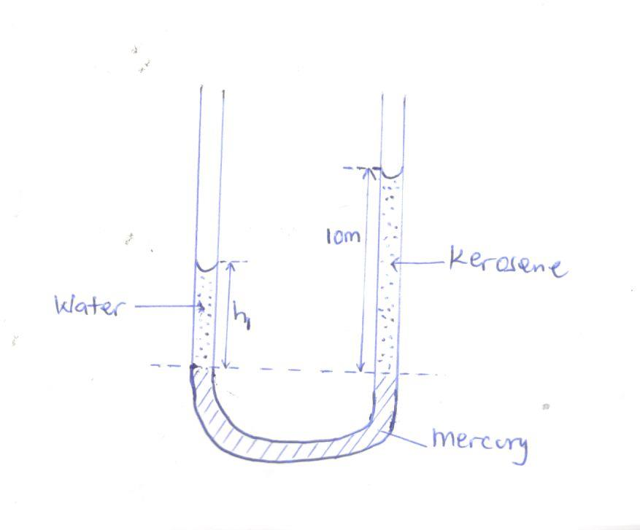
If the density of water is 1000kgm⁻³ and density of kerosene being 800kgm⁻³, calculate the height h₁
(l)

Dam

Turbines

Water

The Figure shows a hydroelectric generating system.

- State the energy transformations that occur during the generation of hydroelectric power in the correct order in which they occur.
- Explain briefly the shape of the dam.

End

