GRAPHIC ART (612/5)
This is refers to the use of both visual images and letters of different styles to communicate or express ideas or message. Letters, images and shapes are used to communicate message.
PROCESS OF GRAPHIC DESIN
- Identifying a problem
- Investigating or taking detailed study of the problem.(involves sketching, note taking, lettering and making layout.
- Providing a clear solution using letters.
ELEMENTS OF GRAPHIC DESIGN
- Colour
- Letters
- Illustration
- Layout/designs
- Contrast.
Colour. This refers to what the eye perceives when ligt is reflected off an object or a surface.
CHRACTERISTICS OF COLOURS
- Graphical colours are flat
- Contrasting colours are used in most case
- Bright colours are mostly used.
Letters, this refers to different symbols that are used to communicate none verbally. They era widely used in newspapers, magazines, and brochures etc.
CHRACTERISTICS OF LETTERS
- Lower cases letters are used
- Upper cases letters are used
- Numerals are also used.
Illustrations, this refers to the visual images that are used to pass on information.
A wide range of inspiration are used eg animals, humans and other objects both living and non-living.
Flat colours or tones are in most cases used to produce images in graphics.
Layout, or design, it involves arrangement of visual elements such as lines, shape, letter and images to create a composition.
Various forms of designs are used and they includes,
Symmetrical balance
Asymmetrical balance
Radial balance’
DEFFERENT ASPECTS OR FEATURES OF GRAPHIC DSIGN
- Logos
- Trade marks
- Emblems
- Badges
- Cartons
- Book covers
- Packaging design
- Lettering.
Logos. This refers to the use of combined letters to represent a word.
A logo is summarized a symbol of a company and it is a registered mark of the company.
CHRACTERISTICS OF A LOGO
- A logo represents only one company
- A logo is made in a short form and always simplified.
- A logo is composed of letters and in some cases illustrations are used.
- A logo is always brief
- Bold letters are used.
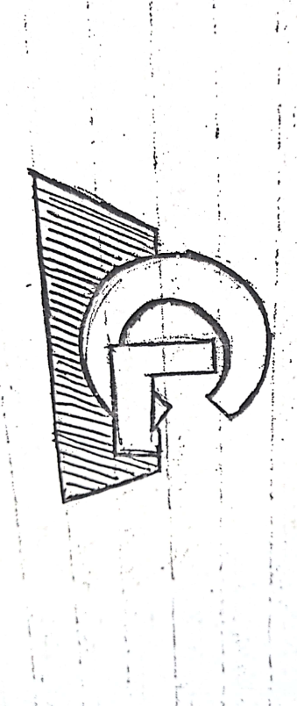
BOOK COVER
This refers to outer surface covering of a book.
It is mostly produced / made using strong and hard material to provide protection to the information inside a book
The design of a book cover are determined by the artists.
CHRACTERISTICS OF A BOOKCOVER
- It should have a title made in bold letters
- It should have three parts/sections ie Front page, Spine, Back page
- It should have illustrations to back up the topic
- It should have the author.
- It should have a publisher
- It should have coloured that brings out its beauty
- It should have a well design layout that combine different elements and principles of art.
Budges
The badge is worn to show affiliation/ belonging/membership of a particular group such as school, club, an association. They are also worn to show a given rank eg head, deputy etc.
Characteristic of a budge
- It should have a name of a school or an association
- It should have an image or illustration depicting activities done.
- It should have a ribbon where the motto is put
- It should have colours
- It should have a good layout
QUESTIONS
1. Design a book cover entitled ‘VEGETABLES IN UGANDA’ written by Vero kire and published by mica publishers. Work within an area of 16cm x 20cm x 3cm. use not more than three colours.
2. In an area of 16cm x 18cm and using not more than three colours, design a logo for ‘MAGEGE FISH COMPNY’ a leading fish exporter in your country.
3. In not more than three colours and using an area measuring 24cmx 16cm x 2cm, design a cover of a book entitled ‘The world is crazy’ by latigo Mathew to be published by peacock bookshop (U) Ltd.

STUDIO TECHNOLOGY (612/1)
CERAMICS
It refers to the art of producing clay objects which are highly fired in a kiln to turn them into a hard brittle material.
MATERIALS AND TOOLS
MATERIALS
- clay
- water
- glaze
- oxides
TOOLS
- Sieve
- Basin
- Kiln
- Potter’s wheel
- Thin wire
CLAY
It refers to the natural fine earth material that is plastic when wet ant hard after firing.
PROPERTISE OF CLAY
Plasticity, it refers to the elasticity of clay.
It is the ability of clay to turn into different forms and shape (manipulated)
Porosity. This is the ability of clay to absorb water, air and other fluids.
This allows formed clay bodies to dry without developing lines of weakness or cracks.
Virtrification. This is the ability of clay to turn into a glassy substance during firing in order to make it strong.
TYPES OF CLAY
Primary clay, it is the type of clay found near the rock source like kaolin.
Secondary clay. It is the type of clay that has been removed from its rock source like ball clay, stone ware, shale etc.
Ball clay, it is very plastic.
It can blend with low plastic clays to increase plasticity.
It cannot be used alone to produce pots.
Kaolin clay, this type is near pure residual clay.
It has low plasticity and high degree of resistance to heat.
It can withstand high temperatures without fusion or decomposition.
It is the same as china clay which is used to produce tiles.
Shale clay, it is the commonest of all clays.
Used to produce bricks building block and tile.
Stone ware clay, this is sedimentary clay used for construction of bricks and tiles.
Fire clay, this is clay has low plasticity.
It is used for making fire bricks and insulation bricks.
It doesn’t mix with other clays.
Porcelain, they fire at very high temperatures.
METHODS OF PREPARING CLAY
- Dry method
- Semi dry method
- Wet method
- Plastic method
PROCESS OF PREPARING CLAY
- Mine clay from the nearby swamp.
- Sort out the impurities from clay like stones, plat roots
- Spread the clay on papers under sunshine to dry completely.
- Pound it to make a powder form
- Sieve the clay to remove all the impurities
- Soak the clay in water and then wedge it to make it plastic.
- Store the clay in a moist place or container and then cove to prevent absorption of water and drying.
TECHNIQUES OF CERAMICS/POTTERY.
Pinch method, under pinch, a lump of clay is rolled into a ball and then pinched using a thumb and finger to form shape.
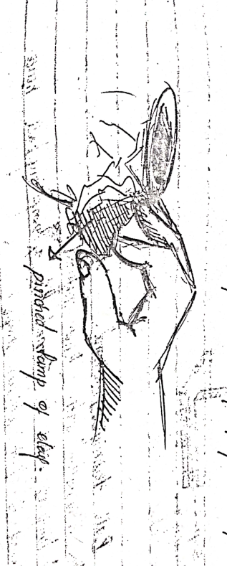
Coil method, this involves the use of rolled clay built successively upon each other to create the required shape.

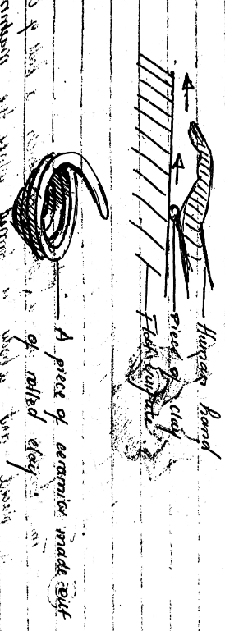
Slab method, it is used to make forms from rolled clay slabs. Slabs are joined together using slip clay.

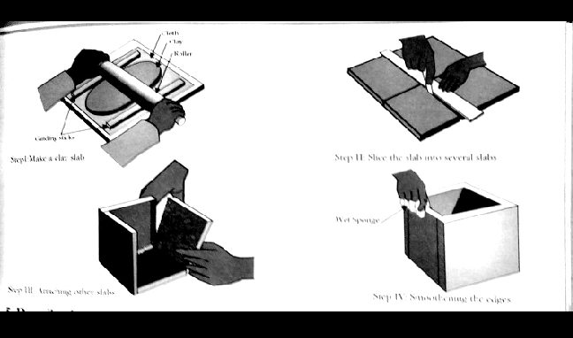
Ball method, a lump of clay is formed into a big ball hence pressed to form a given shape.
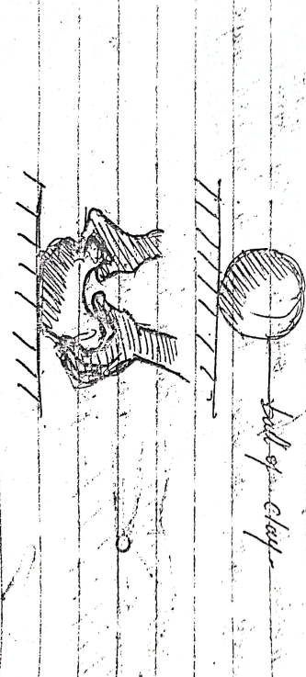
Throwing method, this involves the use of a potter’s wheel on which a ball of clay is placed and a body is formed while the machine rotates.
The following key points are considered when producing a wheel work.
Centering
Hollowing
Pulling up
Shaping.

DECORATIVE CERAMICS FORMS
Use of marks, it involve use of finger or tools but at times its accidental. It helps to create beauty on the surface.
Sgraffito and engobe, its Greek word that’s means scratching using many sharp points at ago. Here any instrument like fork, comb can be used to create marks on the surface.
Burnishing, when a form is hard it can be polished by rubbing with a smooth objects.
Slip trailing, different clay slip can be applied through spraying dipping and sponging.
Note: all slip is fixed to be applied should possess the same firing temperature.
Impressions, design can be created by impressing object into moist clay forms. then coloured slip is fixed to occupy the marks created
Incising, shapes are created using any suitable sharp instrument like a hook, chisel etc.
Inlaying, ceramics forms can be inlaid with a cutout shapes can be the same colour as the clay body or can form a construct. Slip is used to fix the inlaid shapes to the clay.
Painting, here, paints are applied to pottery using brushes after first firing and then overlaid with a glaze.
GLAZING CERAMICS FORMS
It is a vitreous substance used to cover ceramics ware in order to make them attractive, durable and resistant to liquids.
Glaze is powder in its primary state (before firing) and becomes glassy after firing.
TYPES OF GLAZES
Transparent glaze, this type of glaze is clear and the colour of the clay body is clearly seen when such a type used.
Opaque glaze, this type is non transparent, it does not allow the colour of the clay body to be seen. The colour of the glaze depends on the oxides.
Gloss glaze, this is a type of glaze which is smooth and glass like.
They are highly reflective and brilliant.
Matt glaze, they are not brilliant
They are not rough and more porous
They can be used to make unique effects.

FIRING
During firing clay changes from raw materials to a permanent material.
TYPES OF KILNS
Bonfire kilns/ local kilns, a hollow is created and ceramics/ pottery is pilled and assembled then firewood and grass is used to heat the ceramics and pottery.
Bonfire kiln is considered to be a traditional type of kiln.
The gas kiln, this type of kiln uses gas to fire the ceramics ware and it has the most important section called the refractory box where the pieces are pilled.
Electric kilns, these kilns normally use electric power to operate and they vary from size, shape, and brand.
TYPES OF FIRING
Bisque fire, this is first firing of raw ceramic ware (green ware). This is normally done on dry unfired clay pieces and it turn them plastic
Glaze/ gloss fire, during this firing powder glaze is turned into a glassy coating which fuses permanently on the surface of the clay piece.
Decorative fire, this type of fire is used to over glaze and bodies. The glaze is applied an already fired glaze.
Terms used in ceramics
Slip, this is clay dissolved in water.
Green ware, it refers to the clay object that has not been fired.
Kiln, it is a special oven where clay objects are fired from.
Leather hard, it is the condition of unfired clay objects when most of the moisture content has left.
Bone dry, it is the condition of unfired clay when all the moisture has been lost.
Glazing, refers to a method of pottery decoration in which a glassy coating known as glaze is applied to pottery to decorate and protect it.
SCULPTURE.
It is the art of shaping real or abstract three dimension forms in the round or relief by curving, casting, building or construction.
MATERIALS AND TOOLS USED IN SCULPTURE.
Materials
• Wood
• Stone
• Clay
• Metal
• Cement
• Fabrics
• Plastic
• Soap
• Wax
• Paper etc.
Tools
• Panga
• Knife
• Mallet
• Gorge
• Chisel
• Sand paper
• An axe etc.
TYPES OF SCULPTURE.
They are mainly two types of sculpture and these include the following,
- Relief sculpture, it refers to the type of sculpture that is curved into or out of a flat surface or slab. Under this type of sculpture we have the following forms,
Low relief sculpture, this is a form of relief sculpture with slightly low projected images out of slab or surface.
High relief, this is where images are highly projected from the flat surface or slab.
Sunken relief sculpture, this is the type of relief sculpture where images are engraved or scooped from a flat surface
- Round sculptures, this the type of sculpture where images or forms stand in a free space ie when they have no supporting base. This type of sculpture can be viewed from all sides or angles eg statue of liberty, independence monument.

ELEMENTS OF SCULPTURE
Voids, these are space which are partially enclosed by solid of a sculptural art piece.
It can also be referred to as negative spaces of sculptural art work.
Solids, these are three dimension masses that occupy space and projects out. These can be raised or low and solid is supposed to be packed basing on material used.
Planes, this refers to area of a surface which is defined by more or less abrupt change in direction. A plane can be made flat or curved in simple terms, planes are different faces on sculptural body.
Texture, refers to a surface feel of a sculptural artwork. This can be either rough or smooth.
Lines, these are contours defined on an object. Here mainly rods and wires are referred to as lines in sculpture.
Colour/tones, tone refers to darkness or lightness of a sculptural body. Tone can be determined by shape of sculptural body. Ie flat bodies have flat tone, curved bodies have dark to light.
TECHNIQUES USED IN SCULPTURE
Sculpture by subtraction, this technique involves cutting away parts of mass until a required shape is achieved or created. This technique can be used for both relief and round sculpture for example wood curving.
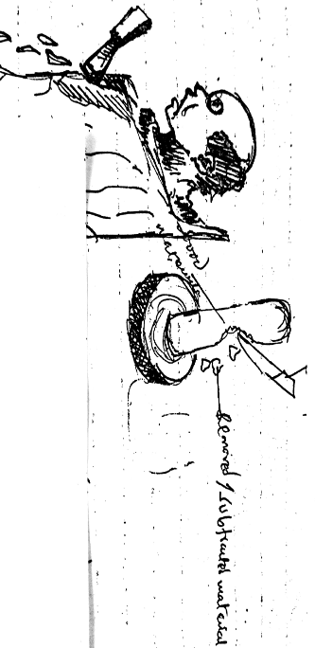
Sculpture by addition, this technique involves adding materials to building a form. Here one can do modeling, construction.
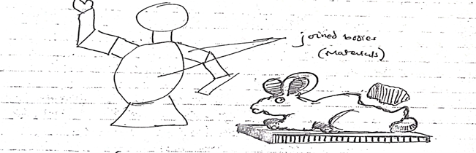
Sculpture by casting, this technique involves producing sculptural artworks by pouring liquid clay or molten metal in to the mold and then material is left to cool down which mold is later separated to remove the product made.
Sculpture by construction,
Sculpture by modeling,
TERMS USED IN SCULPTURE
1. An armature, it is the Skelton frame work of a sculpture and it is made out of wires and bars.
The process of making an armature
Depending on the size of the sculpture to be made, a wooden block is selected
A wire frame in form of a Skelton is made by cutting and shaping the wire into the desired shape according to the sketch.
Craft wires can be covered with aluminum foils on solid parts such as feet and hand pads and chest to help achieve the reality of such parts.
Using nails, the Skelton is affixed on to the wooden block to form the Skelton’s base completing an armature.
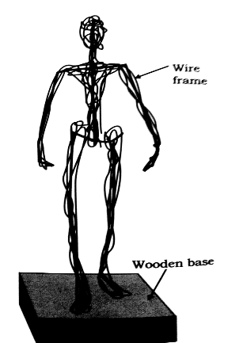
2. A marquete, it is a small model or a sample that represents a final product. It reflects the features of a final product, for example shape, colour, materials, etc and this can be out of clay, cement, plaster of Paris, soap, paper.
FUNCTIONS OF SCULPUTRE.
- Used for spiritual purposes like the sculpture of St Joseph
- They sold for money
- Used for academic purposes as teaching aid.
- For monumental purposes like the independence monument
- For decoration purposes
- For cultural purposes.
- Some sculpture are used on ceremonies like the face masks especially among the African tribes.

