GRAPHIC ART (p615/3)
This is refers to the use of both visual images and letters of different styles to communicate or express ideas or message. Letters, images and shapes are used to communicate message.
PROCESS OF GRAPHIC DESIN
- Identifying a problem
- Investigating or taking detailed study of the problem.(involves sketching, note taking, lettering and making layout.
- Providing a clear solution using letters.
ELEMENTS OF GRAPHIC DESIGN
- Colour
- Letters
- Illustration
- Layout/designs
- Contrast.
Colour. This refers to what the eye perceives when light is reflected off an object or a surface.
CHRACTERISTICS OF COLOURS
- Graphical colours are flat
- Contrasting colours are used in most case
- Bright colours are mostly used.
Letters, this refers to different symbols that are used to communicate none verbally. They era widely used in newspapers, magazines, and brochures etc.
CHRACTERISTICS OF LETTERS
- Lower cases letters are used
- Upper cases letters are used
- Numerals are also used.
Illustrations, this refers to the visual images that are used to pass on information.
A wide range of inspiration are used eg animals, humans and other objects both living and non-living.
Flat colours or tones are in most cases used to produce images in graphics.
Layout, or design, it involves arrangement of visual elements such as lines, shape, letter and images to create a composition.
Various forms of designs are used and they includes,
- Symmetrical balance
- Asymmetrical balance
- Radial balance’
DEFFERENT ASPECTS OR FEATURES OF GRAPHIC DSIGN
- Logos
- Trade marks
- Emblems
- Badges
- Cartons
- Book covers
- Packaging design
- Lettering.
Logos. This refers to the use of combined letters to represent a word.
A logo is summarized a symbol of a company and it is a registered mark of the company.
CHRACTERISTICS OF A LOGO
- A logo represents only one company
- A logo is made in a short form and always simplified.
- A logo is composed of letters and in some cases illustrations are used.
- A logo is always brief
- Bold letters are used.
BOOK COVER
This refers to outer surface covering of a book.
It is mostly produced / made using strong and hard material to provide protection to the information inside a book
The design of a book cover are determined by the artists.
CHRACTERISTICS OF A BOOKCOVER
- It should have a title made in bold leters
- It should have three parts/sections ie Front page, Spine, Back page
- It should have illustrations to back up the topic
- It should have the author.
- It should have a publisher
- It should have coloured that brings out its beauty
- It should have a well design layout that combine different elements and principles of art

QUESTIONS
- Design a book cover entitled ‘African beauty’ written by Lapenga ucam and published by green publishers limited. Work within an area of 16cm x 20cm x 3cm. use not more than three colours.
- In not more than three colours and in an area of 15cm x 15cm, design a logo for ‘Palambo poutry farm’.
- In not more than three colours and using an area measuring 24cmx 16cm x 2cm, design a cover of a book entitled ‘The world is crazy’ by latigo Mathew to be published by peacock bookshop (U) Ltd.

STUDIO TECHNOLOGY (P615/4)
Studio technology
It refers to the study of fine art concepts and how they are done.
Studio.
It is a work place for an artist, like art room gallery.
GALLERY
It is a place where artworks are kept and displayed for both academic and financial purposes.
CRAFTS
Is a work of art skillfully produced by hands and traditional materials. Eg pottery, sculpture, curving, weaving, mosaic etc.
TYPES OF CRAFTS
- Decorative crafts
- Fashion crafts
- Textile crafts
- Function crafts
DECORATIVE CRAFTS, These are crafts produced for decorative purposes eg mosaic, sculpture, collage, curving.
Fashion crafts, these are crafts meant to decorate the human bodies such as bead work, shoes belts, wallets, necklaces, earrings etc.
Textile crafts, these are crafts which involve treatment of a fabric to create designs eg fabric decoration, weaving, applique, printing.
Functional crafts, these are crafts produced for a specific purposes, such as pottery is used for keeping water, mats are used for sitting o, baskets are used for carrying food.
MATERIALS AND TOOLS USED IN MAKING CRAFTS
MATERIALS. These are substances from which an art work is produced. For examples
- Paper
- Yarn
- Banana fiber
- Fabrics
- Stones
- Clay
- Water
- Beads
- Leather
- Glass
- Paint
- Glue
- Paste
- Ink
TOOLS, this is a device used to work on a material for example,
- Paint brush
- Potter’s wheel
- Cutter
- Basin
- Loom
- Razor blade
- Needle
- Frame
ELEMENTS AND PRINCIPLES OF ART AND DESIGN.
ELEMENTS.
These are components of combined together to produce an art work such as line, shape, tone, etc.
Line, it is a mark made on a surfaces by moving point or path.
TYPES OF LINES
- Dotted line.
- Dashed line
- Zigzag lines
- Vertical lines
- Thick lines
- Diagonal lines
- Curved lines
- Horizontal line.
CATEGORIES OF LINES
Actual lines, these are lines we deliberately make with our tools examples are lines drawn using brushes, pencils or pens.
Implied lines, these are lines suggested by the arrangement of objects, shapes or textures.
They are lines perceived by the eye as lines but don’t exist in reality. Examples are lines made when two sharp colours neighbor each other.
USES OF LINES
- It is used to create tone
- Create pattern
- Show mood of a given object
- Create shape of an object
- Create movement and direction
- To create design
- To create texture
Shape, it is an enclosed area with well-defined boundaries. Categories of lines.
- Regular/geometric shapes eg square, triangle, rectangle, circle etc.
- Irregular/organic shapes eg stones, leaves, trees, flowers etc.
Tone, it is the lightness or darkness due to light effects.
It is the variation from dark to light on a surface of an object as light falls on it.
USES OF TONE
- It is used to create form.
- To create texture.
- Shows weight of an object
- To create shape.
Texture, it is the surface quality of an object.
Or
It is roughness or smoothness of an object.
Form, this is the roundness of a given object that is in three dimensional space, mass or volume. Form is mainly created by sketch and tone.
Space, is an area with in and around an object.
TYPES OF SPACE
Negative space, this is an area that has not been occupied by an object.
Positive space, this is an area that has been occupied by an object.
Colour, this is how the eye perceives reflected light off the surface of an object.
TYPES OF COLOUR
- Primary colours, these are colours that cannot be got by mixing two or more colours such as red, yellow, blue.
- Secondary colours, these are colours that are got by mixing two primary colours such as
Yellow+ red = orange
Red + blue = purple/violent
Yellow + blue = green.
- Tertiary colours, these are that are obtained by mixing a primary colour with its neighboring secondary colour.
Yellow + orange = yellow-orange
Red + orange = red-orange
PROPERTISE OF COLOUR.
- Colour hue, this the pure state of a colour unmixed and unmodified.
- Colour value, it is the relative darkness or lightness of a colour.
Tint, this is when white is mixed with another colour to make it litter. eg
Red + white = pink
Green + white = lemon green
Shade, this is when a colour is mixed with black to make it darker. Eg
Red + black = maroon.
- Colour intensity, this is the relative purity of a colour.
Terms used in colour.
- Complimentary colours, these are colours that are opposite each other on a colour wheel. Ie when complementary colours are placed besides each other in equal proportion they compete with each other and create an intense effect.
- Warm colours, these are usually associated with sources of heat and light, such as fire and sun. eg red, yellow and orange
- Warm colours are used in compositions to create feelings of warmth, anger, activity and life. They are vibrant colours.
- Cool colours, these are colours that associated with things like water, vegetation, space, and distance sky in visual compositions. Eg blue, green, purple etc.
- Cool colours can be used effectively to create feelings of coolness, sadness, calmness etc.
THE COLOUR WHEEL.
‘draw colour wheel with all primary, secondary and tertiary colours’

PRINCIPLES OF ART AND DESIGN.
These are guidelines followed when organizing the elements of art and design. Eg
- Balance, it’s the state of equilibrium in an art work. It is achieved when an artist arranges elements of art and design to create a state of equality ie. When all sides are equal.
TYPES OF BALANCE.
- Symmetrical balance, it is also known as formal or passive balance. This is a type of balance achieved when opposite sides of an object in respect to a horizontal or vertical axis are equal.
- Asymmetrical balance, it is also known as informal or active balance. It is the type of balance, the weight and attractions on each side of the axis are balanced by elements which are not identical.
- Radial balance, this is a type of balance achieved when elements are equally distributed starting from the center.
- Proportional, this refers to the relationship in size, height, amount (volume) and location of something compared to another. Eg comparing a human head with a human leg.
- Rhythm,it refers to the visual movement observed in a given work of art. This can be achieved by repetition of elements and principles of art
Techniques of creating rhythm in a composition
Repetition, this can be achieved by repetition of similar lines, shapes, colour, texture and value. These elements are placed at a regular intervals throughout the composition.
Alternation, this create by arranging elements to follow each other alternately, for examples triangular and circular shape may be repeated to alternate both in shape and size.
Progression, it is where the form changes every time it is repeated.
- Unity, this refers to the wholeness achieved in a composition due to effective use of elements and principles of art and design. This achieved when given elements seems to be working together in term of the used elements of art and design.
- Emphasis, this is a principle of art that an artist uses to create dominancy or focal point in an art work.
How to create emphasis in an art work.
- By using shapes ie bigger shape always dominate smaller shapes
- By using stronger contrast between light and dark
- By using brighter colours to dominate dull colours
- By using thick and dark lines to dominate light lines.
- Variety, it the use of a number of elements of and principles of in an artwork like shape, tones etc.,
- Harmony, this is the use of similar principles of art and elements throughout the art work.
- Perspective, it refers to the illusion of depth caused in an artwork due to distance.
TYPES OF PERSPECTIVE.
Linear perspective, this is a type of perspective that deals with shape and size where images in the front tend to be bigger than those in far distance.
Aerial perspective, it is the type of perspective that deals with tone and colour where the the images in the front tend to be darker than those in far distance.
SKETCHING.
This is a stage of the design process in which a preliminary drawing capyurin essentials of the subject such as form, volume light, is produced to be used as a guide in executing a more refined artwork or craft.
IMPORTANCE OF SKETCHING
- Artist uses sketches to communicate their ideas to clients
- Working sketches are a proof of the originality of the idea.
- Through sketching artist rapidly explores and develops various concepts.
- Sketching evaluate the practicability of the design and its features.
- It shows how one is creative through generation of a number of ideas about one item.
- It helps in mainly critics of any idea in order to make additional or subtraction parts.
MOSAIC
It is the art that involves the assemblage and pasting of a single material (tesserae) to produce an artwork.
MATERIALS AND TOOLS USED
MATERIALS
- Beads
- Banana fiber
- Glass
- Stones
- Seeds
- Glue
- Cassava flour
- Paper
- Grout
- Base surface
TOOLS
- Cutter
- Razor blade
- Needle
- Frame
- A pair of scissors
- Rubber
- Sand paper
- Glass cutter
- Spatula
- Gloves
- hammer

TERMS USED IN MOSAIC
Adhesive, this the glue that is used for attaching the tesserae to the base.
Grout, is a cement like mixture used to fill the gaps between the tesserae in a mosaic artwork
Tesserae, refers to broken small pieces of material such as glass, tile used to create a mosaic artwork.
Interstices, these are small spaces that are left between the tesserae
Shimmering, it is the shiny effect that I caused due to light effect on a mosaic.
METHODS OF MOSAIC
Direct method, this involves direct pasting and gluing of materials onto a supportive surface without any guidance. This mainly done on surfaces that have three dimension quality such as vases, pots.
Indirect method, under this method materials such as tiles are first arranged on the ground aside basing on required arrangements and then transferred onto the surface or wall, flow. This method is most extremely useful for large projects like buildings.
Double in direct method. This is a method that involves use of a sketch (coloured) as the first step and then after the artist transfers his materials onto the surface basing on the coloured space. Here an artist makes sure that the final work looks like the sketch.
PROCEDURE FOR MAKING MOSAIC ART
- Identify the source of inspiration to be used or a topic.
- Develop different sketches of the identified source of inspiration
- Collect and prepare the necessary tools and materials to be used
- Use a pencil to transfer the sketch on a board or supportive surface
- Carefully apply glue onto the surface as you past the materials basing in on the colour arrangement within the sketch.
- After completing the composition trim off the unwanted parts of the surface.
- Frame your work to look attractive.
FACTORS CONSIDERED WHEN MAKING A MOSAIC ARTICLE
- Function of the art work
- Composition
- Location of the artwork
- Materials to be used
- Finishing.
PROCESS OF GROUTING
- On a flat clean surface , mix the grout
- Add coloured in the grout in case needed
- Using a plastic spatula, fill the spaces between the tesserae
- Use the spatula to carefully scrape off excess grout using a damp sponge
- Leave it to dry over a night using a soft piece of cloth to polish the surface.
Sample Questions.
1. How can depth and movement be created in a mosaic
2. In your opinion, what are some of the disadvantages of making mosaic as a form of craft?
3. How are the ideas of mosaic art in dairy life utilized in building and construction?
COLLAGE
It is the art that involves the assemblage and pasting of a number of different materials to create textured material.
TOOLS AND MATERIALS
Materials
- Paper
- Leather
- Glass
- Fiber
- Beads
- Stones
- Cement
- Glue
Tools
- Nails
- Scuppers
- Knife
- Scissor
- Hummer
- Cutters
TECHNIQUES USED IN MOSAIC
Montage, it is the process of composition a picture out of photographs, magazines pictures, newspaper, etc to create an art work inform of a composition.
Photomontage, this involves use of photo images to create a picture in form of a composition.
PROCEDURE OF MAKING COLLAGE
- Identify the topic to be worked on
- Make several sketches about the idea inform of a composition
- Collect the necessary tools and materials to be used
- Carefully apply glue onto the surface as you paste the materials
- After completing the art piece trim off the unwanted parts of the surface
- Frame your work to look attractive.
FACTORS CONSIDERED WHEN MAKING A COLLAGE ARTICLE
- Functions of the art work
- Composition
- Location of the art work
- Materials
- finishing
DIFFERENCE BETWEEN SAND COLLAGE AND PAPER COLLAGE
Sand collage is where sand stained with different colours is glued on to a background base to create a collage WHILE paper collage is where small pieces of pare are glued to the background base to create an artwork

CERAMICS
It refers to the art of producing clay objects which are highly fired in a kiln to turn them into a hard brittle material.
MATERIALS AND TOOLS
MATERIALS
- clay
- water
- glaze
- oxides
TOOLS
- Sieve
- Basin
- Kiln
- Potter’s wheel
- Thin wire
CLAY
It refers to the natural fine earth material that is plastic when wet ant hard after firing.
PROPERTISE OF CLAY
Plasticity, it refers to the elasticity of clay.
It is the ability of clay to turn into different forms and shape (manipulated)
Porosity. This is the ability of clay to absorb water, air and other fluids.
This allows formed clay bodies to dry without developing lines of weakness or cracks.
Virtrification. This is the ability of clay to turn into a glassy substance during firing in order to make it strong.
TYPES OF CLAY
Primary clay, it is the type of clay found near the rock source like kaolin.
Secondary clay. It is the type of clay that has been removed from its rock source like ball clay, stone ware, shale etc.
Ball clay, it is very plastic.
It can blend with low plastic clays to increase plasticity.
It cannot be used alone to produce pots.
Kaolin clay, this type is near pure residual clay.
It has low plasticity and high degree of resistance to heat.
It can withstand high temperatures without fusion or decomposition.
It is the same as china clay which is used to produce tiles.
Shale clay, it is the commonest of all clays.
Used to produce bricks building block and tile.
Stone ware clay, this is sedimentary clay used for construction of bricks and tiles.
Fire clay, this is clay has low plasticity.
It is used for making fire bricks and insulation bricks.
It doesn’t mix with other clays.
Porcelain, they fire at very high temperatures.
METHODS OF PREPARING CLAY
- Dry method
- Semi dry method
- Wet method
- Plastic method
PROCESS OF PREPARING CLAY
- Mine clay from the nearby swamp.
- Sort out the impurities from clay like stones, plat roots
- Spread the clay on papers under sunshine to dry completely.
- Pound it to make a powder form
- Sieve the clay to remove all the impurities
- Soak the clay in water and then wedge it to make it plastic.
- Store the clay in a moist place or container and then cove to prevent absorption of water and drying.
TECHNIQUES OF CERAMICS/POTTERY.
Pinch method, under pinch, a lump of clay is rolled into a ball and then pinched using a thumb and finger to form shape.
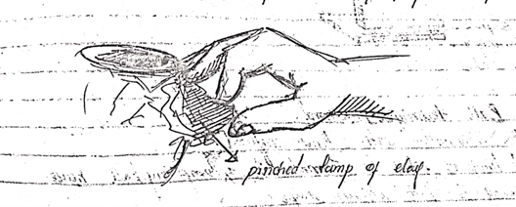
Coil method, this involves the use of rolled clay built successively upon each other to create the required shape.
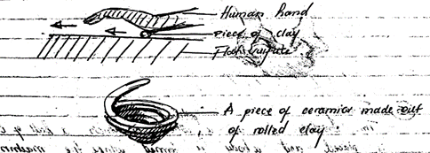
Slab method, it is used to make forms from rolled clay slabs. Slabs are joined together using slip clay.
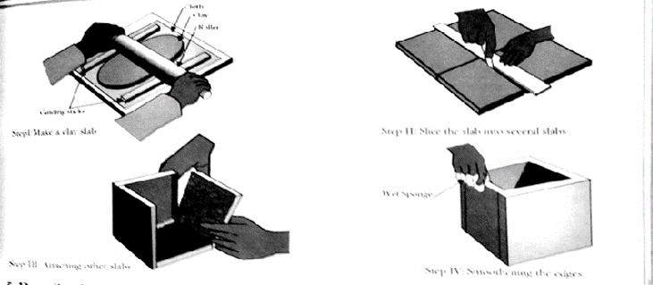
Ball method, a lump of clay is formed into a big ball hence pressed to form a given shape.
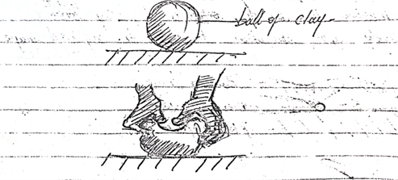
Throwing method, this involves the use of a potter’s wheel on which a ball of clay is placed and a body is formed while the machine rotates.
The following key points are considered when producing a wheel work.
Centering
Hollowing
Pulling up
Shaping.
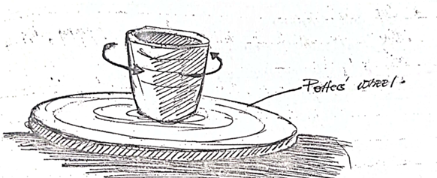
DECORATIVE CERAMICS FORMS
Use of marks, it involve use of finger or tools but at times its accidental. It helps to create beauty on the surface.
Sgraffito and engobe, its Greek word that’s means scratching using many sharp points at ago. Here any instrument like fork, comb can be used to create marks on the surface.
Burnishing, when a form is hard it can be polished by rubbing with a smooth objects.
Slip trailing, different clay slip can be applied through spraying dipping and sponging.
Note: all slip is fixed to be applied should possess the same firing temperature.
Impressions, design can be created by impressing object into moist clay forms. then coloured slip is fixed to occupy the marks created
Incising, shapes are created using any suitable sharp instrument like a hook, chisel etc.
Inlaying, ceramics forms can be inlaid with a cutout shapes can be the same colour as the clay body or can form a construct. Slip is used to fix the inlaid shapes to the clay.
Painting, here, paints are applied to pottery using brushes after first firing and then overlaid with a glaze.
GLAZING CERAMICS FORMS
It is a vitreous substance used to cover ceramics ware in order to make them attractive, durable and resistant to liquids.
Glaze is powder in its primary state (before firing) and becomes glassy after firing.
TYPES OF GLAZES
Transparent glaze, this type of glaze is clear and the colour of the clay body is clearly seen when such a type used.
Opaque glaze, this type is non transparent, it does not allow the colour of the clay body to be seen. The colour of the glaze depends on the oxides.
Gloss glaze, this is a type of glaze which is smooth and glass like.
They are highly reflective and brilliant.
Matte glaze, they are not brilliant
They are not rough and more porous
They can be used to make unique effects.

FIRING
During firing clay changes from raw materials to a permanent material.
TYPES OF KILNS
Bonfire kilns/ local kilns, a hollow is created and ceramics/ pottery is pilled and assembled then firewood and grass is used to heat the ceramics and pottery.
Bonfire kiln is considered to be a traditional type of kiln.
The gas kiln, this type of kiln uses gas to fire the ceramics ware and it has the most important section called the refractory box where the pieces are pilled.
Electric kilns, these kilns normally use electric power to operate and they vary from size, shape, and brand.
TYPES OF FIRING
Bisque fire, this is first firing of raw ceramic ware (green ware). This is normally done on dry unfired clay pieces and it turn them plastic
Glaze/ gloss fire, during this firing powder glaze is turned into a glassy coating which fuses permanently on the surface of the clay piece.
Decorative fire, this type of fire is used to over glaze and bodies. The glaze is applied an already fired glaze.
Terms used in ceramics
Slip, this is clay dissolved in water.
Green ware, it refers to the clay object that has not been fired.
Kiln, it is a special oven where clay objects are fired from.
Leather hard, it is the condition of unfired clay objects when most of the moisture content has left.
Bone dry, it is the condition of unfired clay when all the moisture has been lost.
Glazing, refers to a method of pottery decoration in which a glassy coating known as glaze is applied to pottery to decorate and protect it.
SCULPTURE.
It is the art of shaping real or abstract three dimension forms in the round or relief by curving, casting, building or construction.
MATERIALS AND TOOLS USED IN SCULPTURE.
Materials
- Wood
- Stone
- Clay
- Metal
- Cement
- Fabrics
- Plastic
- Soap
- Wax
- Paper etc.
Tools
- Panga
- Knife
- Mallet
- Gorge
- Chisel
- Sand paper
- An axe etc.
TYPES OF SCULPTURE.
They are mainly two types of sculpture and these include the following,
- Relief sculpture, it refers to the type of sculpture that is curved into or out of a flat surface or slab. Under this type of sculpture we have the following forms,
Low relief sculpture, this is a form of relief sculpture with slightly low projected images out of slab or surface.
High relief, this is where images are highly projected from the flat surface or slab.
Sunken relief sculpture, this is the type of relief sculpture where images are engraved or scooped from a flat surface
- Round sculptures, this the type of sculpture where images or forms stand in a free space ie when they have no supporting base. This type of sculpture can be viewed from all sides or angles eg statue of liberty, independence monument.
ELEMENTS OF SCULPTURE
Voids, these are space which are partially enclosed by solid of a sculptural art piece.
It can also be referred to as negative spaces of sculptural art work.
Solids, these are three dimension masses that occupy space and projects out. These can be raised or low and solid is supposed to be packed basing on material used.
Planes, this refers to area of a surface which is defined by more or less abrupt change in direction. A plane can be made flat or curved in simple terms, planes are different faces on sculptural body.
Texture, refers to a surface feel of a sculptural artwork. This can be either rough or smooth.
Lines, these are contours defined on an object. Here mainly rods and wires are referred to as lines in sculpture.
Colour/tones, tone refers to darkness or lightness of a sculptural body. Tone can be determined by shape of sculptural body. Ie flat bodies have flat tone, curved bodies have dark to light.
TECHNIQUES USED IN SCULPTURE
Sculpture by subtraction, this technique involves cutting away parts of mass until a required shape is achieved or created. This technique can be used for both relief and round sculpture for example wood curving.
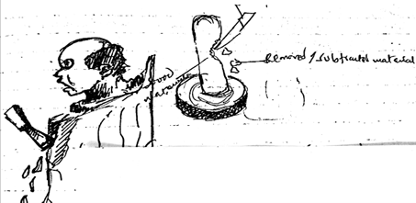
Sculpture by addition, this technique involves adding materials to building a form. Here one can do modeling, construction.
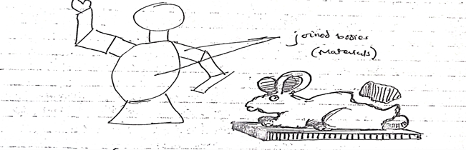
Sculpture by casting, this technique involves producing sculptural artworks by pouring liquid clay or molten metal in to the mold and then material is left to cool down which mold is later separated to remove the product made.
Sculpture by construction,
Sculpture by modeling,
TERMS USED IN SCULPTURE
- An armature, it is the Skelton frame work of a sculpture and it is made out of wires and bars.
The process of making an armature
Depending on the size of the sculpture to be made, a wooden block is selected
A wire frame in form of a Skelton is made by cutting and shaping the wire into the desired shape according to the sketch.
Craft wires can be covered with aluminum foils on solid parts such as feet and hand pads and chest to help achieve the reality of such parts.
Using nails, the Skelton is affixed on to the wooden block to form the Skelton’s base completing an armature.
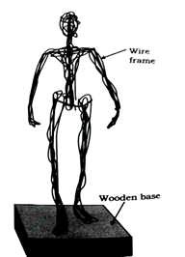
2. A marquete, it is a small model or a sample that represents a final product. It reflects the features of a final product, for example shape, colour, materials, etc and this can be out of clay, cement, plaster of Paris, soap, paper.
FUNCTIONS OF SCULPUTRE.
- Used for spiritual purposes like the sculpture of St Joseph
- They sold for money
- Used for academic purposes as teaching aid.
- For monumental purposes like the independence monument
- For decoration purposes
- For cultural purposes.
- Some sculpture are used on ceremonies like the face masks especially among the African tribes.

