**ST. JOSEPHS SENIOR SECONDARY SCHOOL NAGGALAMA**

**PHYSICS SENIOR ONE**

**EXERCISE**

1. Distinguish between balanced and unbalanced forces.

………………………………………………………………………………………………………………………………………………………………………………………………………………………………………………………………………………………………………………………………

1. Does the footballer in Figure 4.19 exert a contact force or a non contact Force on the ball? Explain your answer.



***Fig. 4.19: Ignatius exerting a force by kicking a ball***

………………………………………………………………………………………………………………………………………………………………………………………………………………………………………………………………………………………………………………………………

1. a) Give two examples where friction is a disadvantage. Explain why this is the case. ………………………………………………………………………………………………………………………………………………………………………………………………………………………………………………………………………………………………………………………………

………………………………………………………………………………………………………………………………………………………………………………………………………………………………………………………………………………………………………………………………

b) Give two examples where friction is a disadvantage. Explain why this is the case. ………………………………………………………………………………………………………………………………………………………………………………………………………………………………………………………………………………………………………………………………

………………………………………………………………………………………………………………………………………………………………………………………………………………………………………………………………………………………………………………………………

1. You have been given sheets of four different materials: sandpaper, polished wood, rubber and plastic. Design an activity to compare the amount of friction when a wooden block is pulled across each of these surfaces. Your account should include: - The apparatus needed. - What you would do. - The results you would expect to obtain. - How you would use the results.

………………………………………………………………………………………………………………………………………………………………………………………………………………………………………………………………………………………………………………………………

………………………………………………………………………………………………………………………………………………………………………………………………………………………………………………………………………………………………………………………………

………………………………………………………………………………………………………………………………………………………………………………………………………………………………………………………………………………………………………………………………

1. Two forces of 12N and 5N act at right angles to each other. Calculate the resultant of these forces.

………………………………………………………………………………………………………………………………………………………………………………………………………………………………………………………………………………………………………………………………

………………………………………………………………………………………………………………………………………………………………………………………………………………………………………………………………………………………………………………………………

1. **Figure below** shows a student walking on a carpet.



The student becomes negatively charged because of the friction between his socks and the carpet. Explain why the friction causes the student to become charged.

………………………………………………………………………………………………………………………………………………………………………………………………………………………………………………………………………………………………………………………………

1. Figure below shows a satellite orbiting the Earth. State the name of the force that keeps the satellite in orbit around the Earth…………………………………………………………………

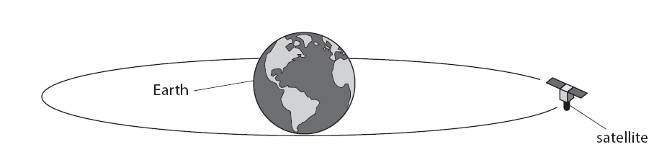

Draw an arrow on Figure 20 to show the direction of the force acting on the satellite that keeps the satellite in orbit around the Earth.

Label this arrow ‘F’.

1. The diagram below shows horizontal forces acting on mulumba at a point while he is accelerating.

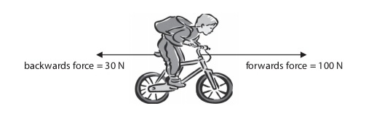

a) Calculate the size of the resultant force acting on mulumba and his bike

………………………………………………………………………………………………………………………………………………………………………………………………………………………………………………………………………………………………………………………………

b) If the total mass of mulumba, his heavy bag and his bike is 55kg, calculate his acceleration.

………………………………………………………………………………………………………………………………………………………………………………………………………………………………………………………………………

END