**ST. JOSEPH’S SSS NAGGALAMA**

**S.4 PHYSICS EXERCISE**

**BY ; Kyaaka Fred**

**Write yours answers in your revision book**

**MODERN PHYSICS**

1. (a) What is meant by
2. **mass number**?
3. **atomic number**?

(b) Name any **three** radiations emitted by radioactive substances.

(c) Explain why alpha particles are more ionizing than beta particles.

(d) State **four** differences between alpha particles and beta particles.

(e) Describe a simple experiment to distinguish between radiations produced by radioactive substances.

(f) Describe a simple atomic model.

1. (a) what are cathode rays?

(b) state **four** characteristics of cathode rays.

(c) Describe an experiment to show that cathode rays travel in straight line.

(d) Describe briefly how cathode rays are produced.

(e) Describe a simple experiment to show that cathode rays are negatively charded.

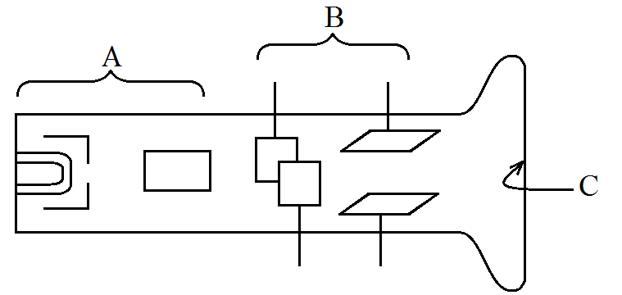

Figure 2 shows the main features of a cathode ray oscilloscope (C.R.O).

(i) Name the parts labeled A, B and C.

(ii) State the functions of the part labeled B.

(iii) State **three** applications of a C.R.O

1. (a) Define the following terms;
2. Radioactivity

(ii) Half life

(b)The activity of a radioactive element with a half-life of 30 days is 2400 counts per second. Find the activity of the element after 120 days.

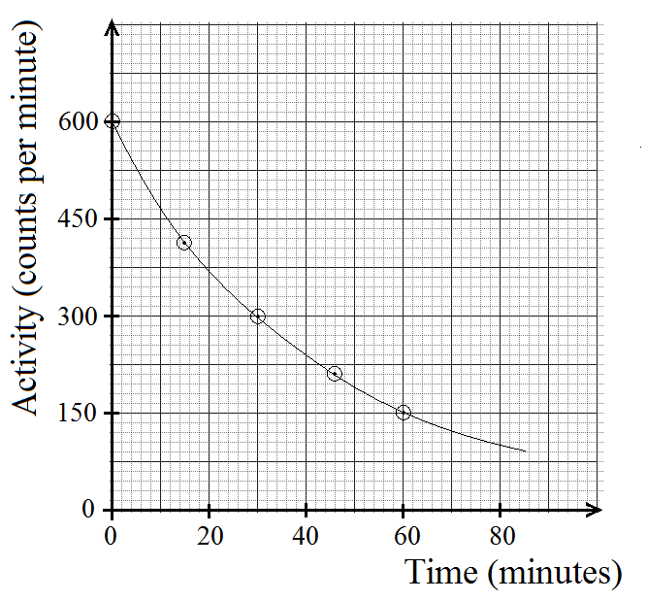

Figure 3 shows a decay curve for a radioactive element. What is the half-life of this element?

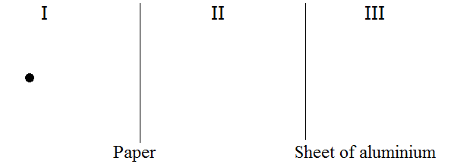

Fig. 3

A piece of paper and a thin sheet of aluminium are placed near a radioactive source as shown in figure 3. If three different types of radiations are emitted, identify the radiations in

1. region I
2. region II
3. region III

(b) What would be the effect of an electric field on radiations in region III?

1. (a) What is meant by **radioactive substance**?

(b) y

The equation above shows a reaction which takes place in a nuclear reactor.

1. Name the reaction shown by the equation.
2. Find x and y.
3. (a) Distinguish between **nuclear fission** and **nuclear fusion**.
4. State the condition for the **two** processes in (a) above to occur.
5. Where does **nuclear fusion** occur naturally?
6. Figure 4 shows the diagram of an X-ray tube.

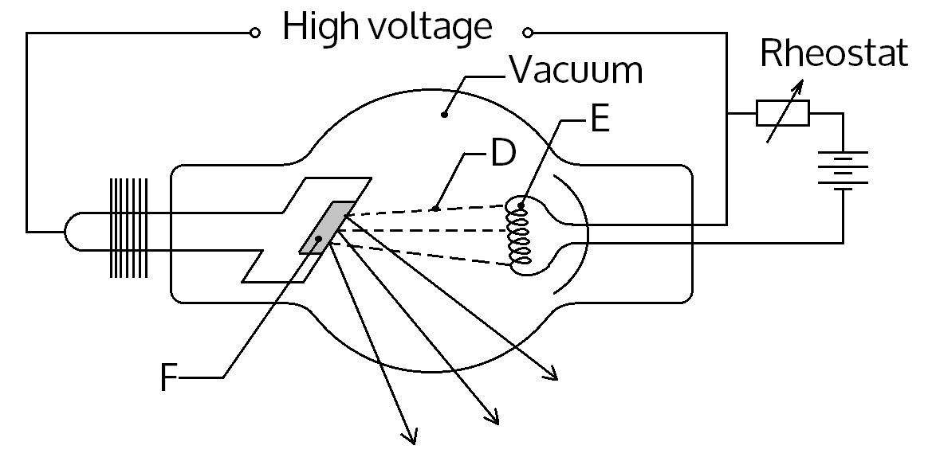

**Figure 4**

1. Name the part labeled E.

(b) What is the function of the part labeled F?

(c) Why is the X-ray tube evacuated?

(d) State two precautions taken when using X-rays.

(e) Describe briefly how x-rays are produced.

8. (a) What are X-rays?

b. State **two** differences between X-rays and gamma rays

c. State **four** uses of X-rays.

(d) Give two differences between Cathode rays and X-rays.

(e) Why is there a cooling system in an X-ray tube?

(f) State **four** properties of X-rays

1. (a) Describe the composition of  nucleus.

(b) A radioactive nuclide emits 3 alpha particles and a new nuclide Y is formed. Write a balanced equation to represent this nuclear change.

(c). Give **two** applications of nuclear energy.

(d) What are **isotopes**?

(e) In which way does the nucleus of uranium 238 differ from the nucleus of uranium 235?

(f) Why can’t isotopes be separated by chemical methods?

1. (a) Isotopes of radioactive element Uranium occur naturally in small proportions in some rocks. The table below gives the information about one isotope of Uranium.

|  |  |
| --- | --- |
| Mass number | 238 |
| Atomic number | 92 |
| Radiation emitted | Alpha particle |

(i) How many neutrons are there in an atom of this Uranium isotope?

(ii) What is the total number of charged particles in a single atom of uranium 238?

(iii) Write a nuclear equation for this Uranium isotope emitting an alpha particle.

(b) State one method of starting nuclear fission.

(c) Account for the energy released in nuclear fusion.

1. Describe briefly how electricity is generated in the nuclear reactor.
2. (a) State **two**;
3. Industrial **uses** of radioactivity.
4. Medical **uses** of radioactivity.
5. The half-life of uranium is 24 days. Calculate the mass of uranium which remains after 120 days if the initial mass is 64 days.
6. State **four** health hazards of radioactivity.
7. State **two** ways of minimizing the hazardous effects of radiations from radioactive material.
8. A radioactive substance of mass 60g takes 400 years for its mass to be reduced to 15g. Find its half-life.
9. (a) Distinguish between **thermionic emission** and **photoelectric emission/effect**.
10. (i) Draw a well labeled diagram of a thermionic diode.

ii.What is meant by **space charge** as applied to a thermionic diode?

1. Define **rectification**.
2. State **two** types of rectification.
3. Distinguish between hard X-rays and soft X-rays.
4. How are hard and soft X-rays produced in an X-ray tube?

**WAVES**

1.(a) What is meant by the term **reverberation**?

(b) State **two** factors which affect frequency of a vibrating string.

(c) A sound wave of frequency 440 Hz has a velocity of 330 ms-1. Calculate its wavelength.

(d) Distinguish between **transverse waves** and **longitudinal waves**

1. The figure below shows a wave produced in a string.

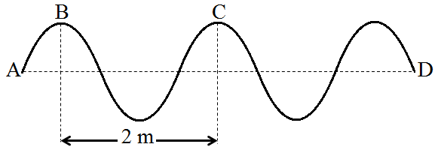

If the frequency is 2 Hz, at what speed do the waves travel along the string?

2.(a) What is an **echo**?

(b) An echo sounder on a boat sends down a pulse through the water and receives its echo 0.9 s later. If the velocity of sound in the water is 1450 ms-1, calculate the water depth.

(c) State any **two** factors which determine the frequency of a note produced when a guitar string vibrates.

(d) What are **sound waves**?

(c) When a hunter fires a gun, an echo from a cliff is heard 8 s later. How far is the hunter from the cliff? (Speed of sound ꞊ 340ms-1)

(d) State **three** practical applications of echoes.

1. (a) What is a **progressive wave**?

(b) What is meant by **antinodes** as applied to a stationary wave?

(c) The distance between two successive antinodes on a stationary wave is 4 cm. Find the wavelength.

(d) What is meant by **wavelength** a longitudinal wave?

(e) Figure 15 shows a sound wave produced from a tuning fork vibrating at 800 Hz.

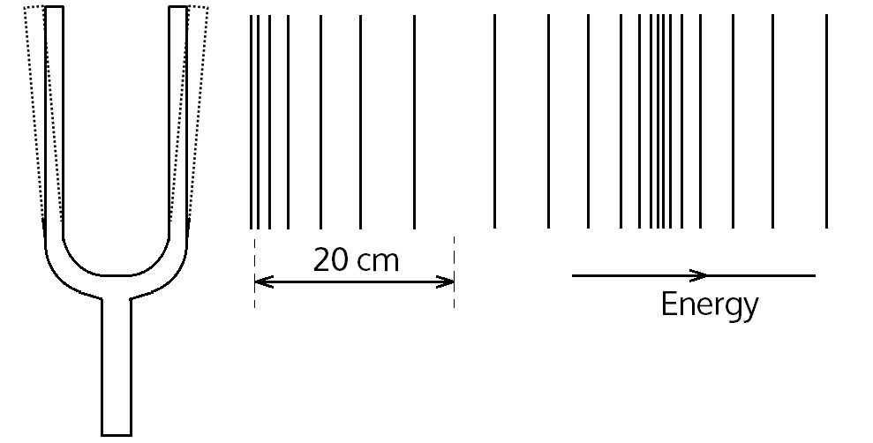

Calculate the velocity of the wave in the medium.

(c) State **three** factors which determine the velocity of sound in air.

1. (a) Forty waves are generated in 2 s. If the waves occupy a distance of 1.6 m, calculate the;

(i) frequency of the waves.

(ii) speed of the waves.

1. The diagram below represents a wave.

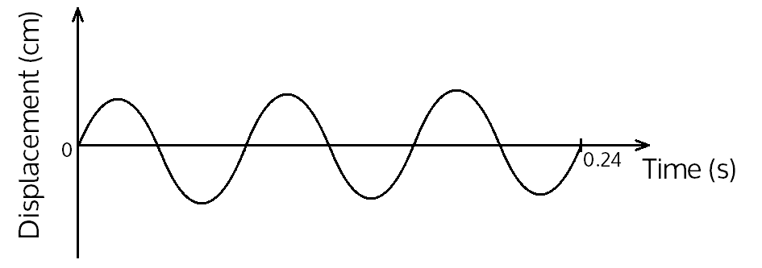

(i) Mark on the diagram the amplitude and label it, A.

(ii) How many cycles are shown on the diagram?

(iii) Calculate the period for wave.

1. (a) (i) Draw diagrams to show the effect of both a narrow gap and wide gap in the path of plane waves.

(ii) Define **interference** of waves.

(b) A radio wave has a wavelength of 300 m. Calculate the frequency of the radio wave.

(c) What is **a stationary** wave?

(d) What is meant by **nodes** as applied to a stationary wave?

(e) The distance between four successive nodes on a stationary wave is 12 cm. Find the wavelength of the wave.

(f) A sounding tuning fork held above the tube produces the first loud sound when the air column is 31 cm above the water surface. (Velocity of sound in air is 320 ms-1).

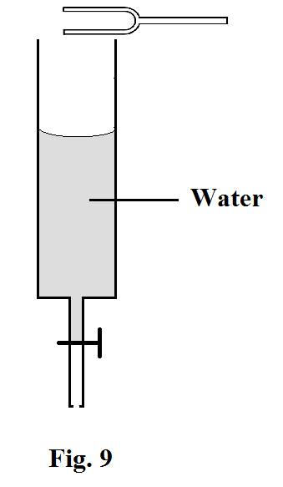

Find the frequency of the tuning fork.

(g) Explain why nothing is heard when the length of the air column is less than 31 cm.

1. (a) Sketch the wave profile of a vibrating string when it produces a
2. fundamental note.
3. second overtone.

(b) A turning fork of frequency 310 Hz produces resonance when the length of a resonance tube above water surface is 130 mm and again when it is 646 mm. Calculate the speed of sound in air.

(c) Define **frequency** as applied to wave motion.

(d) Figure 13 shows a wave profile of a radio wave.

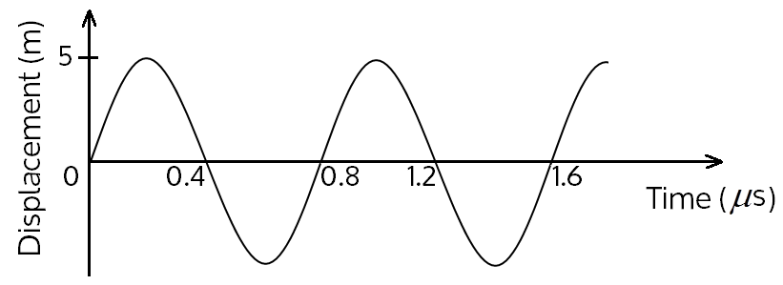

1. Determine the amplitude of the wave.
2. Find the frequency of the wave.
3. (a) Distinguish between **mechanical** and **electromagnetic** waves.

(b) An x-ray radiation has a frequency of 1.5x1010 Hz. Find its wavelength.

(c) Distinguish between **constructive** and **destructive** interference

(d ) State **two** conditions for constructive interference to occur.

(e) Briefly describe how resonance can be obtained in the closed pip

(f ) A long open tube is partially immersed in water and a tuning fork of frequency 425 Hz is sounded and held above it. The tube is gradually raised. Find the length of the air column when resonance first occurs.

1. (a) Define the term **period** as applied to oscillatory motion.

(b) Name **four** examples of electromagnetic waves and state their **uses.**

(c) Distinguish between **compressions** and **rare-factions** as applied to a longitudinal wave.

(d ) Briefly describe how a sound wave is transmitted from a ringing bell to the ear.

1. (a) Distinguish between a **crest** and **trough** as applied to a transverse wave.
2. Describe briefly how communication between the earth and moon is possible in spite of there being no atmosphere around the moon.
3. Define a **wave front**.

(d ) State **two** types of wave fronts.

(e ) Draw a sketch diagram to show how plane waves are reflected by a concave reflector.

**Anode**

**Cathode**

**heater**

**Anode**

**Cathode**

**heater**

**Anode**

**Cathode**

**heater**

**Anode**

**Cathode**

**heater**