Geography Home schooling material
Instructions:
- You will be studying one lesson each day.
- Try to do all activities programmed for each day.
- Remember that some activities may take you more than one hour to complete.
- Read the instructions carefully before you begin doing each activity.
- In case you find any activity difficult, ask an older person around you to assist you.
Lesson 1: Learning Geography through Fieldwork
Learning outcomes
By the end of this lesson, you should be able to:
a. know what fieldwork is.
b. understand how to use and apply different techniques used in fieldwork.
c. use fieldwork to study a local area.
d. appreciate that fieldwork is important because geography is the study of the real world.
Materials you need:
- a notebook,
- pen,
- pencil,
- clipboard,
- rubber,
- telephone hand set or camera (if you can get one)
Activity 1
Walk around your home area and do the following:
1. Look around and write down the natural and built features.
Natural features | Human features

2. Ask people about the activities they carry out in the area and the reasons why they do so.
- ………………………………………………………………………………………………………………………………………………………………………………………………
- ………………………………………………………………………………………………………………………………………………………………………………………………
- ………………………………………………………………………………………………………………………………………………………………………………………………
- ………………………………………………………………………………………………………………………………………………………………………………………………
3. Write a report about what you have found out.
………………………………………………………………………………………………………………………………………………………………………………………………………………………………………………………………………………………………………………………………………………………………………………………………………………………………………………………………………………………………………………………………………………………………………………………………………………………………………………………………………………………………………………………………………………………………………………………………………………………………………………………………
4. Share your findings with your school year mate in the neighborhood if there is one.

How do we study geography through field work?
In order to use fieldwork to get information about a given area, there are certain steps which you have to follow. Also, there are methods which you can use. To help you understand this, do the following Activity.
Activity 2
1. In your exercise book write down the things you did in preparation for the field.
- ………………………………………………………………………………………………
- ………………………………………………………………………………………………
- ………………………………………………………………………………………………
- ………………………………………………………………………………………………
2. If possible, share your work with your school year mate and make comparisons.You have probably written that you created a topic of your study, reasons for the study, and ways of collecting information about the area, planned the route you would follow and where you would end. The reasons for going to the field are called the objectives of the field study. You may also have written down the things you needed to go with. All these activities are called preparation for fieldwork.

Collecting information in the field
Activity 3
In your notebook:
1. Explain how you used the collected information in the field.
- ………………………………………………………………………………………………
- ………………………………………………………………………………………………
- ………………………………………………………………………………………………
- ………………………………………………………………………………………………
2. Suggest a suitable name you can give to each of the methods you have explained in (1) above.
- ………………………………………………………………………………………………
- ………………………………………………………………………………………………
- ………………………………………………………………………………………………
- ………………………………………………………………………………………………
3. Draw a sketch map of the area you studied and on it show physical and human features.

4. If possible, share your work with your school year mate and make comparisons.
Writing a fieldwork report
When we collect information about an area, we use it to write the geography of the area. This is called writing a fieldwork report. This report describes what the area we have studied looks like at the time of our study. Basing on the fieldwork study which you carried out in activity 1, list the things you think should be included in a fieldwork report. Do the following activity to check the list which you have written.
Activity 4
Use the information which you collected in activity 3 to write a field work report of the area around your home. Follow the steps below:
1. Write down the topic and objectives of your study. The topic should include what was studied and where you studied it.
2. Draw a sketch map of the area of your study.
3. Write down the information that you found out about every objective of your study.
4. If you collected any information in form of mathematical figures, present it in tables. You may also represent the same information using charts or graphs.
5. If you took any photographs include them in your report.

Follow-up activity
1. Explain why it is important to learn geography through fieldwork.
- ………………………………………………………………………………………………
- ………………………………………………………………………………………………
- ………………………………………………………………………………………………
- ………………………………………………………………………………………………
2. Carry out a fieldwork study of a farm or a trading centre or a town in your home area.

3. Write a fieldwork report about the study.
………………………………………………………………………………………………………………………………………………………………………………………………………………………………………………………………………………………………………………………………………………………………………………………………………………………………………………………………………………………………………………………………………………………………………………………………………………………………………………………………………………………………………………………………………………………………………………………………………………………………………………………………………………………………………………………………………………………………………………………………………………………………………………………………………………………………………………………………………………………………………………………
Learning Geography through Photographs
Learning outcomes
By the end of this lesson, you should be able to:
a. use maps, aerial images, photographs, to communicate information.
b. recognise the different types of photographs.
c. describe an area from a photograph.
d. appreciate that reading photographs is important because Geography is the study of the real world.
Materials you need:
Photographs of different types, a map of any area, telephone hand set or photographic camera, pen, and pencil.
How can we learn geography from a photograph?
In order to learn about a place, you have not been to, you can use photographs of that place. You will understand this better as you do
Activity 1.
Figure 2.1: A highland area in Kisoro
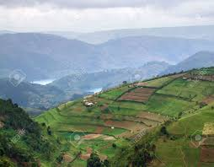
Activity 1
Look at the Figure and do the following:
1. In your notebook, write down the natural and human features shown in the photograph.
- ………………………………………………………………………………………………
- ………………………………………………………………………………………………
- ………………………………………………………………………………………………
- ………………………………………………………………………………………………
2. Explain how the human features are related to the natural features in the area.
- ………………………………………………………………………………………………
- ………………………………………………………………………………………………
- ………………………………………………………………………………………………
- ………………………………………………………………………………………………
3. Suggest how the human features might affect the natural environment in the area shown in the photograph.
- ………………………………………………………………………………………………
- ………………………………………………………………………………………………
- ………………………………………………………………………………………………
- ………………………………………………………………………………………………
4. Explain the difference between a photograph and a map.
- ………………………………………………………………………………………………
- ………………………………………………………………………………………………
- ………………………………………………………………………………………………
- ………………………………………………………………………………………………
Types of photographs
Activity 2
a)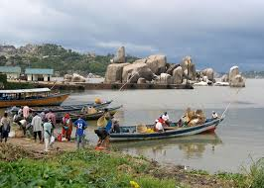 b) 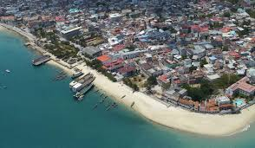
1. Fill in the characteristics of each photograph.
Photograph (a) | Photograph (b)

2. Why do you think the two photographs have different characteristics?
- ………………………………………………………………………………………………
- ………………………………………………………………………………………………
- ………………………………………………………………………………………………
- ………………………………………………………………………………………………

Follow-up activity
1. Using a mobile telephone hand set or a digital camera, if you have one, take a picture of your home and its immediate surroundings.
2. Go to a raised ground or climb a nearby tree and take a picture of the same home again.
3. Compare the two pictures and draw a table with two columns in your notebook to show the features of each photograph.
4. Determine the types of photograph which you have taken. Give reasons to support your classification.

Lesson 3: Describing where Things are on a Photograph
By the end of this lesson, you should be able to:
a. use aerial images and photographs to communicate information.
b. describe information shown on a photograph.
c. appreciate that reading photographs is important because Geography is the study of the real world.
Materials you need:
Photographs of different types, foot ruler, pen, pencil, and rubber
Introduction
Describing positions of the features on ground and oblique aerial photographs
When you look at ground and oblique aerial photographs you see that features nearest to you are bigger than those which are far away. Even roads and rivers become smaller as they move away from you. This is called perspective. The features which are closer to the photographer are normally bigger than those which are far away from the camera. The distance of the features on the photograph enables us to describe where they are.
You already know how to find out where things are on a map. Can you remember some of those ways? Such ways are not the same as the ones you use to describe where features are on a photograph. Unlike a map, a photograph does not have (a word or words are missing); instead it has areas. These are called grounds.

Activity 1
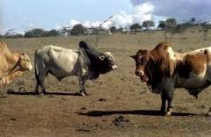
1. Look at the photograph and identify the area where the features appear closest to you. Mark that area across the photograph as the foreground.
2. Identify the area where the features begin to decrease in size. Mark that area across the photograph as the middle ground.
3. Identify the area where the features are furthest from you and are smallest. Mark that area as the background.
4. Identify the area on the photograph which has the sky line or the air above the ground. That one is called the horizon.
5. Now get a foot ruler and a pencil and draw straight lines across the photograph to show where each ground ends.

Activity 2
1. Draw a sketch of the photograph in your notebook and mark the features in each ground.

2. Describe the position of each feature on the photograph.
- ………………………………………………………………………………………………
- ………………………………………………………………………………………………
- ………………………………………………………………………………………………
- ………………………………………………………………………………………………
Activity 4
Look at Figure 3.3 and do the following:
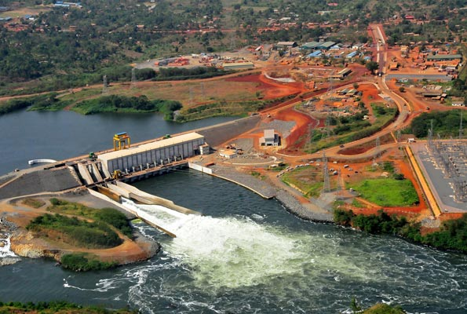
1. Identify the following features on the photograph: river, bridge, natural vegetation, built-up area, and recreation ground.
2. Describe where each feature is found on the photograph.
- ………………………………………………………………………………………………
- ………………………………………………………………………………………………
- ………………………………………………………………………………………………
- ………………………………………………………………………………………………
You have realised that by dividing the vertical aerial photograph into parts like top, bottom, left, right, and centre we can be able to describe the geography of the area it represents.

Follow-up activity
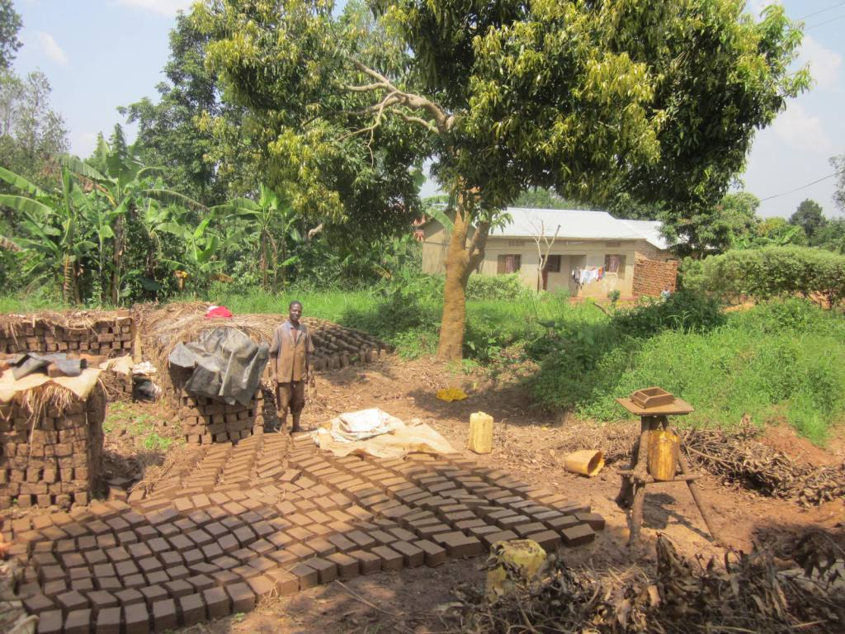
1. Identify the economic activity taking place in the area shown in the photograph.
………………………………………………………………………………………………………
2. What human feature is shown in the background of the photograph?
………………………………………………………………………………………………………
3. Using evidence from the photograph, identify the effects of human activities on the natural environment of the area.
- ………………………………………………………………………………………………
- ………………………………………………………………………………………………
- ………………………………………………………………………………………………
- ………………………………………………………………………………………………
4. Suggest three ways in which the economic activity shown in the photograph benefits the people living in the area.
- ………………………………………………………………………………………………
- ………………………………………………………………………………………………
- ………………………………………………………………………………………………
- ………………………………………………………………………………………………

5. Suggest the time of the day when the photograph might have been taken. Give reasons to support your suggestion.
………………………………………………………………………………………………………………………………………………………………………………………………………………………………………………………………………………………………………………………
6. If possible, share you work with your school year mate and make adjustments.

Finding out information from statistics
Finding out information from statistics
Activity 3
Study the table below showing Tea production in Uganda for different years and do the tasks that follow.
Year | Tea production in tonnes
1986 | 3,300
1987 | 3,500
1988 | 3,500
1989 | 4,200
1990 | 6,600
1991 | 8,300
1. Identify the year when Uganda’s tea production was:
(i) Highest, ………………………………………………………
(ii) Lowest, ………………………………………………………
(iii) Increased most. ………………………………………………………..
(iv) Did not change. ………………………………………………………..
2. Draw a bar graph to show the information in the table above.

3. Compare the table and the graph you have drawn and decide which of the two is easier to understand. Give reasons for your answer.
- ………………………………………………………………………………………………
- ………………………………………………………………………………………………
- ………………………………………………………………………………………………
- ………………………………………………………………………………………………

Research work
1. Carry out an Internet search about the sources of geographical information
- ………………………………………………………………………………………………
- ………………………………………………………………………………………………
- …………………………………………………………………………………………
- ………………………………………………………………………………………………
2. Write a report of your findings.
………………………………………………………………………………………………………………………………………………………………………………………………………………………………………………………………………………………………………………………………………………………………………………………………………………………………………………………………………………………………………………………………………………………………………………………………………………………………………………

3. In your opinion, which source of geographical information is the most important? Give reasons for your answer.
- ………………………………………………………………………………………………
- ………………………………………………………………………………………………
- ………………………………………………………………………………………
- ………………………………………………………………………………………………

4. When schools reopen, hand your report to your teacher of Geography for further assistance.

Follow-up Activity
Get a photograph of any area. You can even use those ones which you used in the earlier lessons or a newspaper cut out.
1. Divide the photograph into suitable grounds
2. Describe the features found in each part of the photograph.
3. Describe the relationship between the features shown in the photograph.
4. Draw a landscape sketch of the photograph and on it mark and name the main features.
The shape and movements of the Earth
Learning Outcomes
By the end of this lesson, you should be able to:
a. understand the shape of the earth.
b. understand the relationship between the earth and the sun and how this affects the temperatures and seasons.
c. draw diagrams to show the relationship between the earth and the sun’s rays and the causes of differences in temperature.
Materials you need
A ball or globe, if possible, an orange, a candle or torch, marker, iron rod or nail, map of the world, secondary school atlas, pencil, pen, and notebook.

Activity 1
Look at the globe, football or an orange and,
1. Identify its top, middle, and bottom.
2. Describe what it looks like at the top, in the middle, and at the bottom.
3. Write about three sentences to describe its shape.
- ………………………………………………………………………………………………
- ………………………………………………………………………………………………
- ………………………………………………………………………………………………
- ………………………………………………………………………………………………

Activity 2
1. Draw a diagram showing the shape of the earth in your notebook and On the diagram indicate the major lines of latitude and longitude.

3. Carry out an internet research about the solar system and write a report of your findings.
………………………………………………………………………………………………………………………………………………………………………………………………………………………………………………………………………………………………………………………………………………………………………………………………………………………………………………………………………………………………………………………………………
4. Remind yourself about the number of planets that make up the solar system.
………………………………………………………………………………………………………
5. Find out why it is called the solar system.
………………………………………………………………………………………………………………………………………………………………………………………………………………………………………………………………………………………………………………………………………………………………………………………………………………………………

The earth makes two types of movements. Can you name them?
- ………………………………………………………………………………………………
- ………………………………………………………………………………………………

Activity 3
Get a friend to help you with this Activity.
1. Get a globe or a ball or an orange, a candle or a torch, and a marker.
2. Using the marker write an X-mark on the ball in case you don’t have a globe.
3. Hold the globe or ball in your hands.
4. Let your friend standing in front of you flash light on the X-mark using a torch.
5. Rotate the globe or ball and observe what happens to the X-mark.
6. Write down what you have observed.
………………………………………………………………………………………………………………………………………………………………………………………………………………………………………………………………………………………………………………………………………………………………………………………………………………………………………………………………………………………………………………………………………
7. Using the observation you have made, explain how day and night form on earth.
………………………………………………………………………………………………………………………………………………………………………………………………………………………………………………………………………………………………………………………………………………………………………………………………………………………………………………………………………………………………………………………………………
Time differences
You have probably heard people talk about 2:00pm East African Standard Time. Other areas like South Africa, America and Britain also have their own time. This means that time is not the same for all places on earth. This is caused by the earth’s rotation. The world Time Zones are based on the Prime Meridian which you learnt about earlier. As you move 15⁰ from the Prime Meridian Eastwards you gain one hour. You will lose one hour for every 15⁰ of longitude you move westwards.
At 12:00 mid-day or noon, the sun reaches its highest position in the sky. At this time the Prime Meridian is under the sun. This is called 12 noon local time along the Prime Meridian. The local Time at Greenwich is called the Greenwich Mean Time (GMT).

Revolution of the earth
It takes a year for the earth to complete its journey around the sun. Can you tell how many days these are? …………………………………………………………………………………………
This complete journey is called a revolution. After every four years, the earth takes 366 days to complete the same journey. The fourth year is called a leap year. All the other years have 365 days.

You will also find that the earth’s revolution leads to changes in the position of the latitudes in relation to the sun. Every year the sun is overhead the equator on two days. The day when the sun is overhead the equator is called Equinox.

Activity 4
1. Find out the days when the earth experiences:
(i) Equinoxes ………………………………………………………………………………..
(ii) Summer and winter solstices ……………………………………………………………

2. Identify the seasons in a year and write at least two sentences to explain what you understand by each season.
- ………………………………………………………………………………………………
- ………………………………………………………………………………………………

The day when the sun is overhead the tropic of Cancer is called the Summer Solstice.
When the sun is overhead the Tropic of Capricorn it is called the Winter Solstice.

Activity 5
1. Carry out internet research about how the four seasons affect people’s activities and ways of life.
2. Write a report of your findings.
- ………………………………………………………………………………………………
- ………………………………………………………………………………………………
- ………………………………………………………………………………………
- ………………………………………………………………………………………………
3. If you can, share your findings with your school year mate and make comparisons.

Activity
- Carry out internet research about world climate zones,
1. Draw a diagram of the earth and on it mark and name the equator, tropic lines, and Arctic and Antarctic circles.

2. Mark out the tropical, temperate, and Polar Regions or zones.
3. Copy the table below in your notebook and complete it by filling in the characteristics of each climatic region.
Climatic region | Characteristics
Tropical region | 2.  3.  4.
Temperate region | 2.  3.  4.
Polar region | 2.  3.  4.
Desert region | 2.  3.  4.

4. Suggest other factors which might cause differences in temperatures of an area.
- ………………………………………………………………………………………………
- ………………………………………………………………………………………………
- ………………………………………………………………………………………
- ………………………………………………………………………………………………
5. If possible, share your work with your school year mate in the neighbourhood and make comparisons.

6. Identify the part of the earth which represents the:
(i) Region around the equator/Equatorial region
………………………………………………………………………………………………………
(ii) Polar regions
………………………………………………………………………………………………………
3. Which of the two regions, Equatorial and Polar, experiences more heating by the sun’s rays?
………………………………………………………………………………………………………
4. Explain why there is a difference in the amount of heating between the equatorial region and Polar Regions.
………………………………………………………………………………………………………………………………………………………………………………………………………………………………………………………………………………………………………………………
Lesson 7: Weather and how it is measured
Learning Outcomes
By the end of this lesson, you should be able to:
a. understand the difference between weather and climate.
b. understand the elements of weather and how they are measured.
Materials you need
notebook, pen, pencil, 2 transparent plastic bottles, a pair of scissors or knife, marker, and foot ruler
What is weather?
Have you ever noticed that some people in your community or even in your own home at times carry umbrellas with them while at other times they carry sweaters and overcoats? What do you think determines the things those people carry with themselves for their journeys? You have probably thought of changes in weather as the reason.
Activity 1
1. Walk around the compound and look at the air and the sky and also feel the temperature of the air around you.
2. How would you describe the weather around your home?
………………………………………………………………………………………………………………………………………………………………………………………………………………………………………………………………………………………………………………………
3. What was the weather like around your home yesterday?
………………………………………………………………………………………………………………………………………………………………………………………………………………
4. Is today’s weather different from that of yesterday or the last three days? If yes, describe the differences.
………………………………………………………………………………………………………………………………………………………………………………………………………………
5. In your own words, explain what you understand by weather.
………………………………………………………………………………………………………………………………………………………………………………………………………………
Elements of Weather
Activity 2
1. List the things you have talked about when describing the weather around your home in activity 1(above).
- ………………………………………………………………………………………………
- ………………………………………………………………………………………………
- ………………………………………………………………………………………………
- ………………………………………………………………………………………………
2. How many things have you used to describe the weather?
………………………………………………………………………………………………………
3. Suggest a name which you can give to the things you have listed.
………………………………………………………………………………………………………

How is weather different from climate?
Activity 3
1. Ask the older person around you the time of the year when your home area experiences:
(i) Heavy rains …………………………………………………………………………….
(ii) Little or no rainfall …………………………………………………………………….
(iii) Hottest temperature ……………………………………………………………………
(iv) Coolest temperature ……………………………………………………………………
(v) Hail storms ………………………………………………………………………………
2. Using the information, you have collected, describe the weather pattern for your home area.
………………………………………………………………………………………………………………………………………………………………………………………………………………………………………………………………………………………………………………………
3. Suggest a name which you can give the weather pattern you have described.
………………………………………………………………………………………………………

Activity 4
1. Identify the types of precipitation.
- ………………………………………………………………………………………………
- ………………………………………………………………………………………………
- ………………………………………………………………………………………………

2. Write at least two sentences to describe each type of precipitation.
………………………………………………………………………………………………………………………………………………………………………………………………………………………………………………………………………………………………………………………………………………………………………………………………………………………………………………………………………………………………………………………………………………………………………………………………………………………………………………

3. Name the type of precipitation which is commonly received in your home area.
………………………………………………………………………………………………………
4. Which of the types of precipitation is not received in Uganda and East Africa?
………………………………………………………………………………………………………
5. Why do you think the type you have mentioned in (4) above does not occur in Uganda and East Africa?
………………………………………………………………………………………………………………………………………………………………………………………………………………
6. Explain what you understand by precipitation.
………………………………………………………………………………………………………………………………………………………………………………………………………………

What is Temperature?
Activity
1. Imagine you have woken up in the morning when there is mist in the air outside. What would you feel on your body?
………………………………………………………………………………………………………………………………………………………………………………………………………………
2. What would you feel on your body if you woke up when the morning is sunny?
………………………………………………………………………………………………………………………………………………………………………………………………………………
3. In about two sentences, explain what you understand by the term temperature.
………………………………………………………………………………………………………………………………………………………………………………………………………………

Follow-up activity
1. Carry out a fieldwork study of your home area to find out how the different types of precipitation affect the:
(i) local community,
- ………………………………………………………………………………………………
- ………………………………………………………………………………………………
- ………………………………………………………………………………………
- ………………………………………………………………………………………………
(ii) natural environment.
- ………………………………………………………………………………………………
- ………………………………………………………………………………………………
- ………………………………………………………………………………………
- ………………………………………………………………………………………………
2. Write a report of your findings.
………………………………………………………………………………………………………………………………………………………………………………………………………………………………………………………………………………………………………………………………………………………………………………………………………………………………

Measuring and Recording Rainfall
You already know that a rain gauge is the instrument for measuring rainfall. In this lesson you are going to learn to make and use your own rain gauge to measure rainfall.
Activity 1
You will need to get the following items:
• 2 litre mineral water bottles or a funnel
• ruler
• maker
• basin or saucepan
• knife or pair of scissors
• masking tape
• nail tile
• polythene sheet (transparent)
Follow the following instructions:
1. Cut one of the bottles into half. Use the top half as a funnel. If there are sharp edges, use the nail tile to cut them.
2. Place the funnel on top of the uncut bottle with the edges touching.
3. Use a masking tape to firmly fix the funnel on the bottle.
4. Put the polythene sheet over the funnel opening and press it slightly inwards.
This is to enable water easily flow into the bottle.
5. Make a hole inside the polythene sheet to direct water into the bottle.
6. On the bottle, use a maker and mark out cm from the bottom upwards with the help of a ruler. Each cm represents 500 millimetres.
7. Place your rain gauge in an open place.
8. Read off and record the amount of rainfall received every 24 hours in your weather log.
9. After a daily or 24 hour records, pour the water and place the rain gauge back.

Activity 2
Study the table
MONTHS | J | F | M | A | M | J | J | A | S | O | N | D
TEMP(⁰C) | 24 | 25 | 24 | 23 | 23 | 22 | 21 | 22 | 22 | 22 | 22 | 23
R/FALL(mm) | 10 | 51 | 89 | 170 | 211 | 145 | 155 | 216 | 170 | 160 | 96 | 43
1. Write down:
(i) The wettest month
………………………………………………………………………………………………………

(ii) Driest month
………………………………………………………………………………………………………
2. Find out the:
(i) annual total rainfall
………………………………………………………………………………………………………………………………………………………………………………………………………………………………………………………………………………………………………………………
(ii) Mean Annual rainfall
………………………………………………………………………………………………………………………………………………………………………………………………………………………………………………………………………………………………………………………
(iii) Annual range of temperature
………………………………………………………………………………………………………………………………………………………………………………………………………………………………………………………………………………………………………………………
3. Draw a bar graph to show the climate of Entebbe.

Location, Size, and Relief Regions of East Africa
Learning Outcomes
By the end of this lesson, you should be able to:
a. know the East African countries, their approximate population and area.
b. locate East Africa on a map of Africa and on the world map.
c. use maps, statistics, graphs, and diagrams to analyse population.
Materials you need
Secondary school atlas, text book on East Africa, Graph paper, notebook, ruler, ICT tools, pen and pencil, and a set of mathematical instruments
Activity
1. Write down the countries that make up East Africa.
- ………………………………………………………………………………………………
- ………………………………………………………………………………………………
- ………………………………………………………………………………………
2. Use your atlas to find out the names of the countries surrounding East Africa.
- ………………………………………………………………………………………………
- ………………………………………………………………………………………………
- ………………………………………………………………………………………
3. Draw a sketch map of East Africa and on it fill in the names of the East African countries and indicate the lines of latitude and longitude between which East Africa lies.

5. Using information from the maps you have drawn, describe the location of East Africa.
………………………………………………………………………………………………………………………………………………………………………………………………………………………………………………………………………………………………………………………
Activity 2
Look at the table showing the area of East African countries and do the tasks that follow.
Country | Area (Km²) | Population
Uganda | 236,040 | 45,741,007
Kenya | 580,367 | 53,771,296
Tanzania | 945,087 | 59,734,218
1. Find the total area of East Africa.
………………………………………………………………………………………………………………………………………………………………………………………………………………………………………………………………………………………………………………………
2. Draw a pie chart to show the population of East African countries.

3. Which country covers the largest area? ......................………………………………………
4. Which country covers the smallest area? ……………………………………………………
Activity 3
Country | Area (Km²) | Population density
Uganda | 236,040
Kenya | 580,367
Tanzania | 945,087
1. Draw a bar graph to show the population of East African countries.

2. Calculate the population density for each country and fill in the table.
………………………………………………………………………………………………………………………………………………………………………………………………………………………………………………………………………………………………………………………………………………………………………………………………………………………………………………………………………………………………………………………………………………………………………………………………………………………………………………………………………………………………………………………………………………………
3. Which country has the highest density of population? .…………………………………………
4. Which country has the lowest density of population? ..…………………………………………

