TOPIC: THE DEVELOPMENT OF TOWNS AND PORTS IN EAST AFRICA

Lesson 2: Growth and development of Ports and Town in EastAfrica
Introduction
You have probably ever seen a town or trading centre at least in your home district. That town or trading centre is somewhat similar to a larger town elsewhere. There are special factors which enabled it to develop in the place where it is found. Have you also ever seen or visited a landing site on a lake or river. If you have ever seen one, its features and the factors that led to its development are also closely similar to those of a port. In this lesson you are going to learn about the major towns and ports of East Africa, and factors which have led to their development.

Activity1

Look at Figure 2.1 and do the following tasks:
- Copy the map into your notebook.
- With the help of the atlas or any other map showing urban areas in East Africa, name:
  - Towns marked
O……………………………….U……………………………..
P……………………………….V…………………………….
R………………………………. W……………………………..
S………………………………….T…………………………………,
  - Ports marked
1……………………
2……………………
3……………………
4……………………

- Describe the distribution of major urban centers in East Africa.

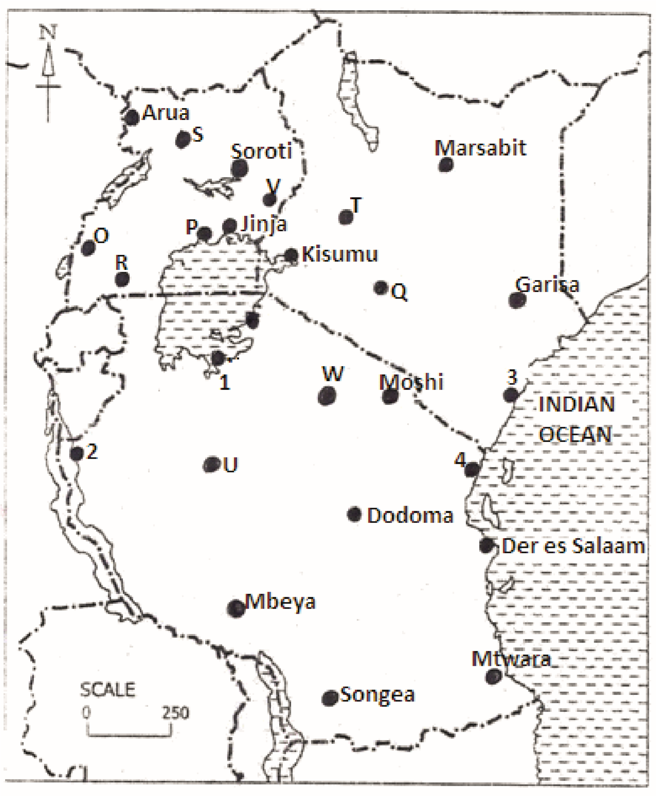

Figure2.1: Map showing major urban centres and ports in East Africa

Factors that led to the growth and development of towns and ports in EastAfrica

Activity 2
Visit the town or trading centre nearest to your home and do the following:
- Draw a sketch map to show the physical and human features in the town and its immediate surroundings.

- Find out stages in the development of the town from the people living in the area.
- ……………………………………………………
- ……………………………………………………
- ……………………………………………………
- ……………………………………………………

- Ask people living in the town whether they were born in that area or not. If not, find out where they came from.

- Find out the activities carried out in the town.
- …………………………………………..
- ………………………………………..
- ………………………………………..
- ………………………………………
- ………………………………………
- ………………………………………..

- Ask people where they get the things they use in everyday life and how they get them.
…………………………………………..
………………………………………..
………………………………………..

- Find out the factors which have led to the development of the town.
…………………………………………………………………………………………………………………………………………………………………………………………………………………………………………………………………………………………………………………………………………………………………………………………………………………………………………………………………………………………………………………………………………………………………………………………………………………………………………………………………………………………………………………………………………………………………………………………………………………………………………………………………………………………………………………………………………………………………………………………………………………………………………………………………………………………………………………………………………………………………………………………………………………………………………………………………………………………………………………………………………………………………………………………………………………………………………………………………………………………………………………………………………………………………………………………………………………………………………………………………………………………………………………………………………………………………………………………………………………………………………………………………………………………………………………………………………………………………………………………………………………………………………………………………………
……………………………………………………………………………………………………………………
- Look around and find out the problems people living in the town face.
- …………………………………………..
- ………………………………………..
- ………………………………………..
- ………………………………………
- ………………………………………
- ………………………………………..
- ………………………………………….
- ………………………………………….
- You could have found out that the town you have studied started as a small Trading post where the local people used to bring their products for sale.
- It could also have been a local administrative Centre? Many towns in other parts of East Africa started in a similar way and expanded overtime.
- Again, you have probably found out that the majority of the people living in the town were not born there, they came from other places.
- Do you remember the name given to the process whereby people move from villages to live permanently in towns?
Have you realized that most of the people in the town are involved in providing services such as selling goods, hair salons and barber services, mechanical repairs and the like? In all towns people are mainly employed in such services.

Activity 3
Copy the table below into your notebook and use it to divide the factors which led to the development of the town you visited as natural and human.

Natural factors | Human factors

Activity
4
Using your knowledge of New York City–Port, and the knowledge of the town you have studied in your home area, explain how each of the following factors could have led to the development of Mombasa port.

- Relief
- Rich hinterland
- Climate
- Presence of a natural harbor
- Presence of minerals
- Strategic location
- Government policy
- Improvement in transport network
- Early contacts with foreign traders
- Administrative functions

Summary
In this lesson you have learnt that:
- Towns and ports develop through several stages starting as small trading posts or service centres.
- Towns in East Africa have developed as a result of several factors including relief, presence of water supplies, good transport network, reliable supply of food and goods from the hinterland, security and stability and others.
- Most towns have developed at junction points for transport routes such as roads, water-ways, and railway lines. Other towns have developed along major transport routes. This is called strategic location.

Follow - up Activity
Study the Table below showing percentage of urban population in East Africa and do the tasks that follow.

Table 1: Percentage of urban population in East Africa
Country | Percentage of urban  Population
Uganda | 12
Kenya | 36
Tanzania | 22

- Draw a pie chart, to represent the information in the table above.
- Suggest reasons why Kenya has a bigger percentage of urban population compared to other East African countries.
………………………………………………………………………………………………………………………………………………………………………………………………………………………………………………………………………………………………………………………………………………………………………………………………………………………………………………………………………………………………………………………………………………………………………………………………………………………………………………………………………………………………………………………………………………………………………………………………………………………………………………………………………………………………………………………………………………………………………………………………………………………………………………………………………………………………………………………………………………………………………………………………………………………………………………………………………………………………………………………………………………………………………………………………………………………………………………………………

LESSON3: Functions of ports and towns
Introduction
In lesson 2 you visited the town in your home area and found out the things that people living in the town do. List some of those things which you remember. The things or activities carried out in a town are called the functions of the town. Different towns have different functions depending on where they are found. In this lesson you are going to learn more about the functions of major towns in East Africa.
Functions of Kampala City
In Senior One, you learnt about New York City and Port. Think of at least five functions of New York City. Kampala City and other cities of East Africa also perform functions which are somewhat similar to those of New York. To understand this better, do the following Activity.
Activity 1
Look at Figure 3.1 and do the following tasks:
- Identify the functions of Kampala City shown in each picture and write them in your notebook.
1…………………………………………………………………………………………………………
2…………………………………………………………………………………………………………
3…………………………………………………………………………………………………………4……………………………………………………………………………………………………….
5……………………………………………………………………………………………………….
6…………………………………………………………………………………………………………
- In about two sentences, explain what each function involves.
1……………………………………………………………………………………………………………………………………………………………………………………………………………………..
2…………………………………………………………………………………………………………………………………………………………………………………………………………………....
3…………………………………………………………………………………………………………………………………………………………………………………………………………………….4……………………………………………………………………………………………………………………………………………………………………………………………………………………..
5…………………………………………………………………………………………………………………………………………………………………………………………………………………..
6…………………………………………………………………………………………………………………………………………………………………………………………………………………
- Briefly explain how each function identified in the figure has attracted people to Kampala City.
…………………………………………………………………………………………………………………………………………………………………………………………………………………………………………………………………………………………………………………………………………………………………………………………………………………………………………………………………………………………………………………………………………………………………………………………………………………………………………………………………………………………………………………………………………………………………………………………………………………………………………………………………………………………………………………………………………………………………………………………………………………………………………………………………………………………………………………………………………………………………………………………………………………………………………………………………………………………………………………………………………………………………………………………………………………………………………
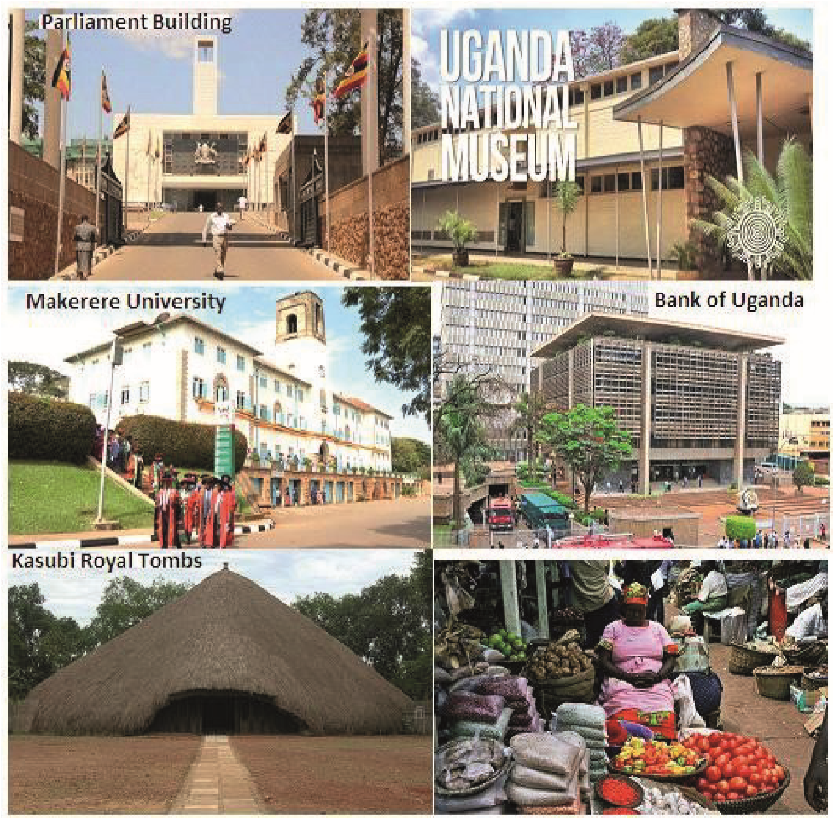
Figure 3.1: Some of the functions of Kampala City

In the above activity, you could have found out that Kampala is a commercial center, cultural centre, administrative centre and so forth. You have also learnt that each of the functions attract more people to the city. This is one of the reasons why Kampala is the largest urban area in Uganda.
However, there are several other functions of Kampala City which are not shown in Figure2. To learn more about these functions, do the following activity.

Activity 2
Look at Figure 3.2 and do the tasks that follow.
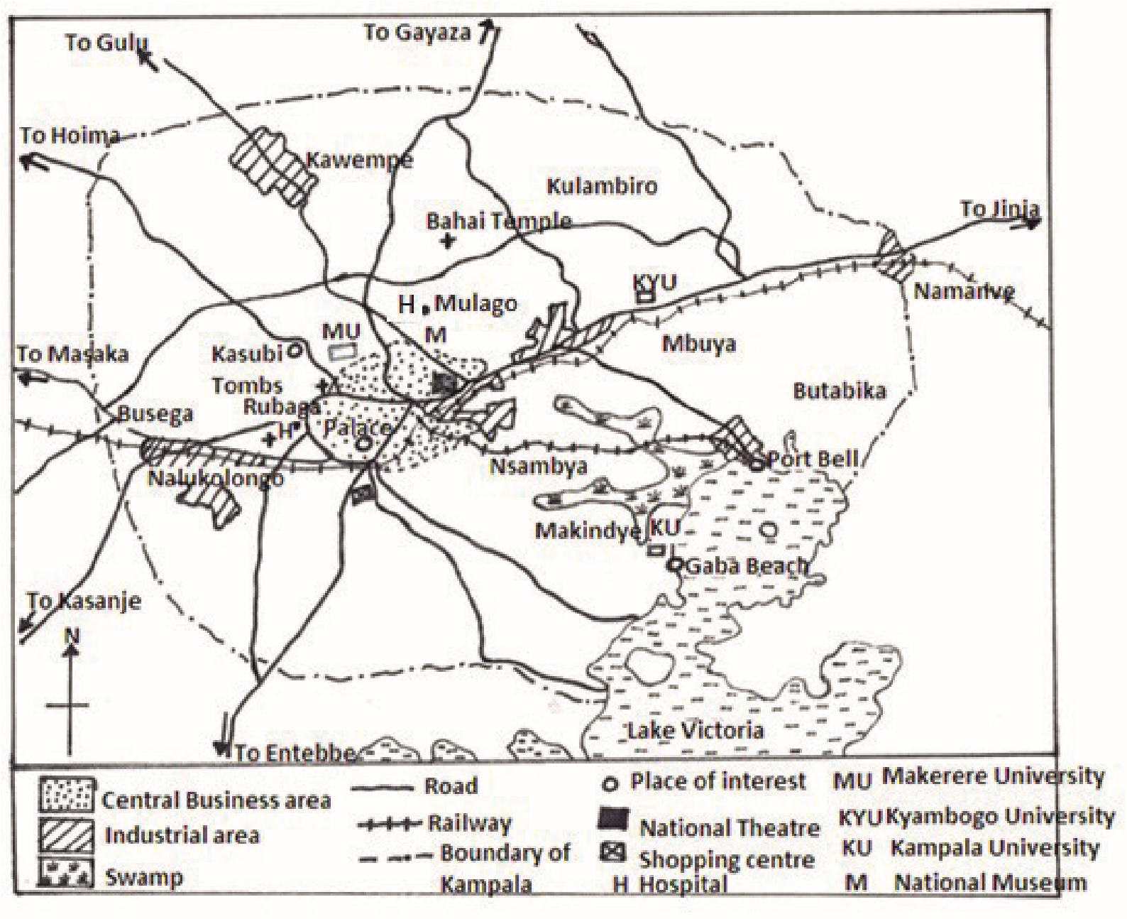
Figure 3.2: Map of Kampala City

- Copy the map in Figure 3 into your note book.
- Using the map, you have drawn and your knowledge of New York City or any other town, identify the functions of Kampala City which are not shown in Figure 2.1in Lesson 2 above.
- Briefly explain how each of the activities you have identified in (1) above, might attract more people to live in Kampala City.

Summary
In this lesson, you have learnt that:
  - The towns and ports in East Africa are collecting centres for people who carry out a wide range of social, cultural, commercial and administrative activities. The activities carried out in these areas are called the functions of towns.
  - Most towns in East Africa are commercial, administrative, residential, industrial, recreational and tourist centers.
  - The functions of a town mainly depend on its location, historical background, size of the population and government policy.
  - The functions of towns are the major factors attracting more people to migrate from rural areas to towns. This leads to an increase in urban population which in turn leads to the expansion of towns.

Follow-up Activity
Carry out textbook or internet research about the functions of Mombasa and Dares Salaam.
  - For each town, draw a sketch map to show its major features and lay out.

  - Explain what each function involves and how it has led to the development of the town.
mombasa
…………………………………………………………………………………………………………………………………………………………………………………………………………………………………………………………………………………………………………………………………………………………………………………………………………………………………………………………………………………………………………………………………………………………………………………………………………………………………………………………………………………………………………………………………………………………………………………………………………………………………………………………………………………………………………………………………………………………………………………………………………………………………………………………………………………………………………………………………………………………………………………………………………………………………………………………………………….
Dar-es-salaam
…………………………………………………………………………………………………………………………………………………………………………………………………………………………………………………………………………………………………………………………………………………………………………………………………………………………………………………………………………………………………………………………………………………………………………………………………………………………………………………………………………………………………………………………………………………………………………………………………………………………………………………………………………………………………………………………………………………………………………………………………………………………………………………………………………………………………………………………………………………………………………………………………………………………………………………………………………….

  - Draw a table to summarise the functions of urban areas in East Africa under the following categories: Social functions, Cultural functions, Commercial functions, and Administrative functions.

Lesson 4: Problems of Urbanization
Introduction
In lesson 1, you learnt about the problems people living in the town nearest to your home face. Again, in Senior Two, you learnt about the problems facing New York City. Do you remember those problems? List them in your notebook.
In this lesson you are going to learn about problems that result from the growth or urban areas and the ever-rising urban population in East Africa.

Activity1
Look at Figure4.1and do the following:

- Identify the problems shown in each of the pictures.
a)……………………………………………………..
b)…………………………………………………
c)……………………………………………………
d)………………………………………………………
- Explain how each problem may affect people living in the urban areas.
a)……………………………………………………..
b)…………………………………………………
c)……………………………………………………
d)………………………………………………………
- For each problem, suggest at least one reason why it occurs.
a)……………………………………………………..
b)…………………………………………………
c)……………………………………………………
d)………………………………………………………

- Suggest measures which can be undertaken by both the governments of East African countries and urban authorities to solve the problems you have identified above.
a)……………………………………………………..
b)…………………………………………………
c)……………………………………………………
d)………………………………………………………

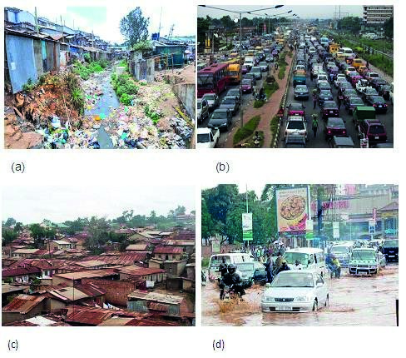

Figure 4.1: Some of the problems of urban areas in East Africa

The problems which you have identified in the previous Activity are faced in almost all the urban areas of East Africa.

However, some problems are more severe in some towns than in others. For example, due to poor dumping of solid domestic, market and industrial wastes, floods have become more severe in Kampala City. This is because the poorly disposed wastes block drainage channels and natural streams making them unable to accommodate runoff water whenever it rains.

Activity 2
Imagine you have visited Nairobi or Mombasa town.
Apart from the problems which you have found, out in Activity 1 above, a) which other problems do you think you would most likely find people in the town facing?

b) Write them down in your notebook and explain how each of them would be affecting both the people and natural environment.

Have you realized that most of the problems facing the urban areas of East
Africa result from the rapid increase of urban population? The number of people living in urban areas increases faster than we can plan. For example, in most towns of East Africa, people lack access to clean water, social services such as schools and medical facilities, housing, and adequate jobs to employ the ever growing population.

However, there are some problems which result from the mixing of people from different cultures. These include loss of traditional cultural values and language, growth of tribal cells such as “Kifumbira”, “Acholi quarters”, “Kiteso” and others, in the case of Kampala. Such tribal cells are centres of social discrimination, and rapid spread of diseases which can be caught through direct contact.

Summary

In this lesson, you have learnt that:

•The growth of urban areas can lead to greater poverty. This comes about when local governments are unable to provide services for all people.
- The burning of fossil fuel as a source of energy leads to greater air pollution which in turn affects human health.
- Urban development increases the risk of environmental hazards such as flooding and outbreak of water borne diseases.
- These problems of urbanisation can be reduced or even solved through better planning of towns, enforcing of laws relating to housing, waste disposal, traffic and conservation of green belts in towns.

Follow-up Activity
- Carry out a textbook or Internet research about the benefits associated with the growth of towns in East Africa.
- Imagine you have been invited to take part in a debate on the motion “East Africa needs to develop rural areas more than towns in order to realise fast development”.
In your note book, prepare the points which you will present at the debate and clearly show your side.
References:

- Gladys Hickman (1994): Lands and People of East Africa. (Pp44-66)
- Carol M. Serwanga, Kaggwa H., and Isanga E. (2011): MK Ordinary Level
- Geography. East Africa, Student’s Book3 (pp.289-312) • MacMillan /Moran Uganda Secondary School, Atlas

TOPIC: TRANSPORT, COMMUNICATION AND TRADE IN EASTA FRICA

Lesson 5: Major types of Transport and Communication in East Africa
Introduction

Transport and communication are important services in promoting the activities people do. Such activities may include trade, tourism, farming, mining, and fishing. Did you know that the need to move raw materials, goods and people results in the creation of transport and communication networks?

In this lesson, you are going to learn about major types of transport and
Communication in East Africa.
Activity1
Look at Figure 5.1and do the following tasks:
- In about three sentences, describe each one of the types of transport shown in the figure.
A……………………………………………………………………………………………………………………………………………………………………………………………………………………………………………………………………………………………………………………………………………………
B………………………………………………………………………………………………………………………………………………………………………………………………………………………………………………………………………………………………………………………………………………….
C………………………………………………………………………………………………………………………………………………………………………………………………………………………………………………………………………………………………………………………………………………….
D………………………………………………………………………………………………………………………………………………………………………………………………………………………………………………………………………………………………………………………………………………….
E………………………………………………………………………………………………………………………………………………………………………………………………………………………………………………………………………………………………………………………………………………….
F………………………………………………………………………………………………………………………………………………………………………………………………………………………………………………………………………………………………………………………………………………….
G………………………………………………………………………………………………………………………………………………………………………………………………………………………………………………………………………………………………………………………………………………….
- Which one of the types of transport shown in the figure have you ever used?
1……………………………………
2…………………………………………
3…………………………………………..
- Explain the advantages and disadvantages of using the type of transport which you have ever used.
1……………………………………….. (Name the type)
Advantages
……………………………………………………………………………………………………………………………………………………………………………………………………………………………………………………………………………………………………………………………………………………………………………………………………………………………………………………………………………………………………………………………………………………………………………………………………………………………………………………………………………………………………………………………….Disdvantages
………………………………………………………………………………………………………………………………………………………………………………………………………………………………………………………………………………………………………………………………………………………………………………………………………………………………………………………………………………………………………………………………………………………………………………………………………..
2……………………………………….. (Name the type)
Advantages
……………………………………………………………………………………………………………………………………………………………………………………………………………………………………………………………………………………………………………………………………………………………………………………………………………………………………………………………………………………………………………………………………………………………………………………………………………………………………………………………………………………………………………………………….Disdvantages
………………………………………………………………………………………………………………………………………………………………………………………………………………………………………………………………………………………………………………………………………………………………………………………………………………………………………………………………………………………………………………………………………………………………………………………………………..

- Which is the most commonly used type of transport in your home area and why?...............................................................................................................................................................................................................................................................................................................................................................................................................................................................................

- Explain what you understand by transport?
………………………………………………………………………………………………………………………………………………………………………………………………………………………………………………………………………………………………………………………………....

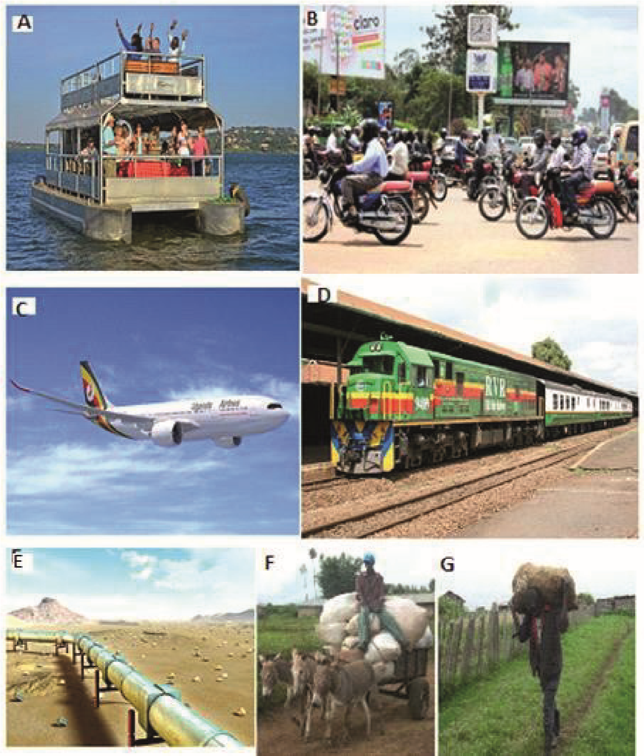

Figure 5.1: Types of transport

In the previous, Activity you have learnt that the choice of the type of transport to be used mainly depends on the nature of goods to be moved from one place to another, the cost involved in using the means, and the relief of the area. For example, many mountain dwellers in East Africa mostly use human portage and animal transport because it is not easy to use vehicles in such areas.

Heavy and bulky goods are conveniently transported by rail since it is cheaper. Similarly, it is cheap to transport petroleum and natural gas in large amounts using pipeline.

Activity2

- Imagine you are a trader dealing in the goods listed below.
- Cut flowers and vegetables for export
- Iron ore from the mine to the factory
- Fresh milk from Mbarara to Kampala
- Maize grain
- Heavy machinery
- For each type of goods, decide the type of transport you would use
Cut flowers and vegetables for export ……………………………………………
Iron ore from the mine to the factory ………………………………………….
Fresh milk from Mbarara to Kampala ……………………………………………..
Maize grain ……………………………………………………………………………………….
Heavy machinery ………………………………………………………………………………..

- Give reasons for your choice in each case.
Cut flowers and vegetables for export …………………………………………..
Iron ore from the mine to the factory ………………………………………….
Fresh milk from Mbarara to Kampala …………………………………………….. Maize grain……………………………………………………………………………………….
Heavy machinery………………………………………………………………………………..

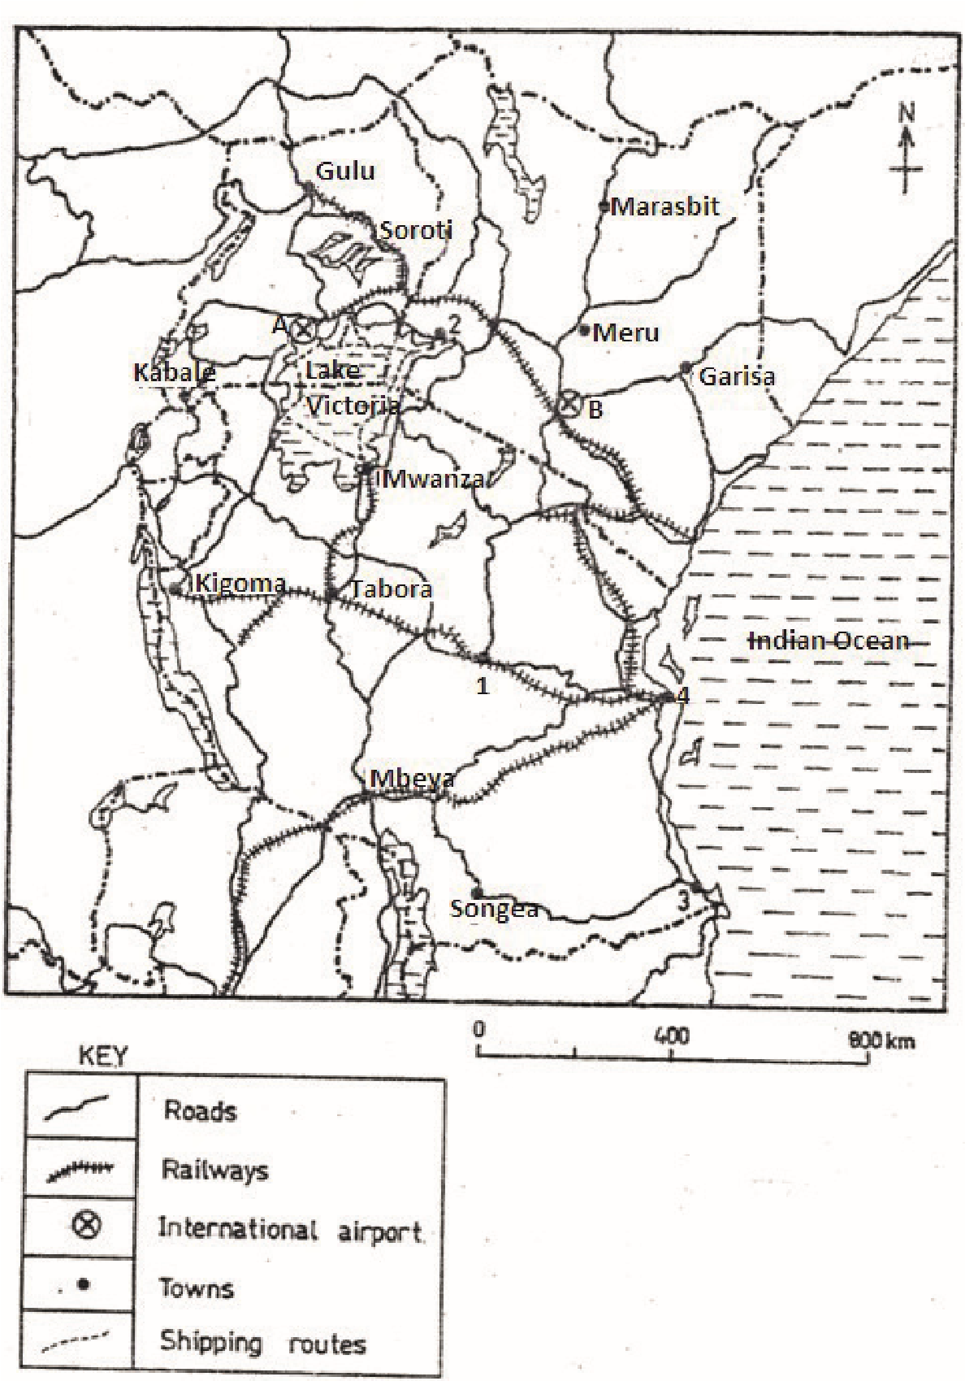
Figure5.2: Major transport networks in East Africa
Activity3
Look at Figure 5.2 and do the following tasks:
- Draw Figure5.2 into your notebook.

- Using the knowledge you got and in the previous topic, name the: (i)Towns marked 1 and 2;
1……………………………………..
2……………………………………
(ii)Port Marked 3,
3……………………………………………..
(iii) The airports marked A and B.
A…………………………………..
B………………………………….

- With the help of the atlas, name the roads and railway lines on your map.
…………………………………………………………………………………………………………………………………………………………………………………………………………………………………………………………………………………………………………………………………………………………………………………………………………………………………………………………………………………………………………………………………………………………………………………………………………………………………………………………………………………………………………………………………………………………………………………………………………………………………………………………………………………………………………………………………………………………………………………………………………………………………………………………………………………………………………………………………………………………
- Briefly explain how factors such as relief, government policies and technology have led to the development of the transport networks above.
…………………………………………………………………………………………………………………………………………………………………………………………………………………………………………………………………………………………………………………………………………………………………………………………………………………………………………………………………………………………………………………………………………………………………………………………………………………………………………………………………………………………………………………………………………………………………………………………………………………………………………………………………………………………………………………………………………………………………………………………………………………………………………………………………………………………………………………………………………………………
- Identify the type of transport which is least used in East Africa.
………………………………………………………………………………………………………………………………………………………………………………………………………………………
- Suggest reasons why the type of transport you have identified in (5) above is the least used.
……………………………………………………………………………………………………………………………………………………………………………………………………………………………………………………………………………………………………………………………………………………………………………………………………………………………………………………………………………………………………………………………………………………………………………………………………………………………………………………………………………………………………………………………………………………………………………………………………………………………………………………………………………………………………………………………………………………………………………………………………………………………………………………………………………………………………………………………………………………………………………………………………………………
Major types of communication

Activity4

Look at Figure 5.3 and do the following tasks:
- Identify the types of communication shown in the figure. In case you fail to identify any one of them, ask the people around you for assistance.
1…………………………….
2………………………..
3…………………………….
4……………………………..
5…………………………..
6……………………………
7………………………………..
8…………………………………..
9………………………………
- Explain how each one of them is used.
1…………………………………………………………………………………………………………………………………………………………..
2…………………………………………………………………………………………………………………………………………………………….
3…………………………………………………………………………………………………………………………………………………………………….
4…………………………………………………………………………………………………………………………………………………………………..
5……………………………………………………………………………………………………………………………………………………………………
6………………………………………………………………………………………………………………………………………………………………….
7……………………………………………………………………………………………………………………………………………………………….
8……………………………………………………………………………………………………………………………………………………………..
9………………………………………………………………………………………………………………………………………………………….
- Suggest the advantages and disadvantages of using each type of
Communication identified above.
1……………………………………………………………name the type
Advantages
……………………………………………………………………………………………………………………………………………………………………………………………………………………………………………………………………………………………………………………………………………………………………………………………………………………………………………………………………………………………………………………………………………………………………………………………………………………………………………………………………………………………………………..
Disadvantages
……………………………………………………………………………………………………………………………………………………………………………………………………………………………………………………………………………………………………………………………………………………………………………………………………………………………………………………………………………………………………………………………………………………………………………………………………………………………………………………………………………………………………………………………………………………………………………………………………………………………..
2……………………………………………………………name the type
Advantages
……………………………………………………………………………………………………………………………………………………………………………………………………………………………………………………………………………………………………………………………………………………………………………………………………………………………………………………………………………………………………………………………………………………………………………………………………………………………………………………………………………………………………………..
Disadvantages
……………………………………………………………………………………………………………………………………………………………………………………………………………………………………………………………………………………………………………………………………………………………………………………………………………………………………………………………………………………………………………………………………………………………………………………………………………………………………………………………………………………………………………………………………………………………………………………………………………………………..
3……………………………………………………………name the type
Advantages
……………………………………………………………………………………………………………………………………………………………………………………………………………………………………………………………………………………………………………………………………………………………………………………………………………………………………………………………………………………………………………………………………………………………………………………………………………………………………………………………………………………………………………..
Disadvantages
……………………………………………………………………………………………………………………………………………………………………………………………………………………………………………………………………………………………………………………………………………………………………………………………………………………………………………………………………………………………………………………………………………………………………………………………………………………………………………………………………………………………………………………………………………………………………………………………………………………………..
4……………………………………………………………name the type
Advantages
……………………………………………………………………………………………………………………………………………………………………………………………………………………………………………………………………………………………………………………………………………………………………………………………………………………………………………………………………………………………………………………………………………………………………………………………………………………………………………………………………………………………………………..
Disadvantages
……………………………………………………………………………………………………………………………………………………………………………………………………………………………………………………………………………………………………………………………………………………………………………………………………………………………………………………………………………………………………………………………………………………………………………………………………………………………………………………………………………………………………………………………………………………………………………………………………………………………..
5……………………………………………………………name the type
Advantages
……………………………………………………………………………………………………………………………………………………………………………………………………………………………………………………………………………………………………………………………………………………………………………………………………………………………………………………………………………………………………………………………………………………………………………………………………………………………………………………………………………………………………………..
Disadvantages
……………………………………………………………………………………………………………………………………………………………………………………………………………………………………………………………………………………………………………………………………………………………………………………………………………………………………………………………………………………………………………………………………………………………………………………………………………………………………………………………………………………………………………………………………………………………………………………………………………………………..
6……………………………………………………………name the type
Advantages
……………………………………………………………………………………………………………………………………………………………………………………………………………………………………………………………………………………………………………………………………………………………………………………………………………………………………………………………………………………………………………………………………………………………………………………………………………………………………………………………………………………………………………..
Disadvantages
……………………………………………………………………………………………………………………………………………………………………………………………………………………………………………………………………………………………………………………………………………………………………………………………………………………………………………………………………………………………………………………………………………………………………………………………………………………………………………………………………………………………………………………………………………………………………………………………………………………………..
7……………………………………………………………name the type
Advantages
……………………………………………………………………………………………………………………………………………………………………………………………………………………………………………………………………………………………………………………………………………………………………………………………………………………………………………………………………………………………………………………………………………………………………………………………………………………………………………………………………………………………………………..
Disadvantages
……………………………………………………………………………………………………………………………………………………………………………………………………………………………………………………………………………………………………………………………………………………………………………………………………………………………………………………………………………………………………………………………………………………………………………………………………………………………………………………………………………………………………………………………………………………………………………………………………………………………..
8……………………………………………………………name the type
Advantages
……………………………………………………………………………………………………………………………………………………………………………………………………………………………………………………………………………………………………………………………………………………………………………………………………………………………………………………………………………………………………………………………………………………………………………………………………………………………………………………………………………………………………………..
Disadvantages
……………………………………………………………………………………………………………………………………………………………………………………………………………………………………………………………………………………………………………………………………………………………………………………………………………………………………………………………………………………………………………………………………………………………………………………………………………………………………………………………………………………………………………………………………………………………………………………………………………………………..
9……………………………………………………………name the type
Advantages
……………………………………………………………………………………………………………………………………………………………………………………………………………………………………………………………………………………………………………………………………………………………………………………………………………………………………………………………………………………………………………………………………………………………………………………………………………………………………………………………………………………………………………..
Disadvantages
……………………………………………………………………………………………………………………………………………………………………………………………………………………………………………………………………………………………………………………………………………………………………………………………………………………………………………………………………………………………………………………………………………………………………………………………………………………………………………………………………………………………………………………………………………………………………………………………………………………………..

- Which type of communication is most commonly used in your home area?
Suggest reasons why it is the one used most commonly.
- Which one is least used? Why?
- In about two sentences, explain what is meant by communication.

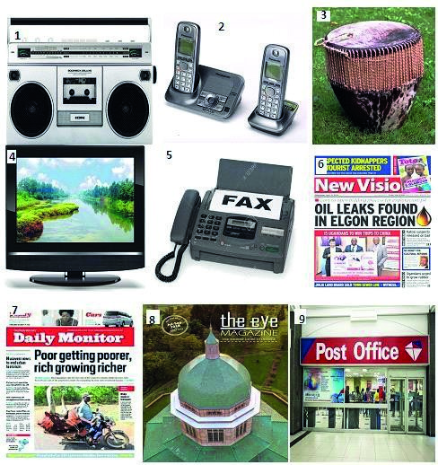

Figure 5.3: Types of Communication

In the previous Activity, you have learnt what communication is, the main types of communication, the advantages and disadvantages of each type of communication. You have also found out the things we consider to choose the type and means of communication we use.
Factors influencing the development of transport and communication Uganda, unlike Kenya and Tanzania, has no direct access to the sea. It is a landlocked country. Because of her location, she faces a number of problems in transporting her goods to and from the coast.
Activity4
- Carry out a textbook or internet research and find out the factors
Influencing transport networks in East Africa.
- Draw a table with two columns and classify the factors you have found out in (1) above.
Summary
In this lesson, you have learnt that:
- Transport is the movement of people and goods from one place to
Another.
- Communication involves the transmission of ideas and information between people and places.

- The major types of transport are water, air, human portage, animal, railway, and road. Pipeline transport is used in the transportation of petroleum, natural gas and copper powder.

- Road transport is the most commonly used type of transport in
East Africa.
- The most commonly used means of transport depend on the nature of the area. For example, mountainous areas often use human portage, areas with water bodies use boats, ships and ferries. Similarly bicycles are used in rural areas to carry people and light load.
- Factors influencing the development of transport and communication are both physical and human. They include relief, drainage, level of technology reached and government policy.
Follow up Activity
Study the table below showing the types of transport used in Uganda by percentage and do the tasks that follow.

Typesof transport | Percentage of transport type
Own vehicle | 5.7
Public transport | 39.3
Motor bike | 1.4
Non-motorised bikes | 15.0
On head/shoulder/back | 17.1
Other | 2.1
Hired vehicle | 20.0

- Draw a bar graph to represent the above information.

- Road accidents are very common in East Africa. Explain the causes of road accidents.

……………………………………………………………………………………………………………………………………………………………………………………………………………………………………………………………………………………………………………………………………………………………………………………………………………………………………………………………………………………………………………………………………………………………………………………………………………………………………………………………………………………………………………………………………………………………………….
- Imagine you have been appointed an officer in charge of traffic in your home area. What advice would you give to the road users in order to reduce accidents?
- …………………………………………………………………………………………………………………………………………………………………………………………………………………………………………………………………………………………………………………………………………………………………………………………………………………………………………………………………………………………………………………………………………………………………………………………………………………………………………………………………………………………………………………………………………………………………………………………………………………………………………………………………………

References:
- Gladys Hickman (1994): Lands and Peoples of East Africa (pp 154-155 ;

178-181)

- Carol M. Serwanga, Kaggwa H., and Isanga E. (2011): MK Ordinary Level

Geography. East Africa, Student’s Book 3(pp.313-327)

- Young and Lowry (1977): Acourse in World Geography; East Africa.

