Nyumbani at home
Utangulizi introduction
Je, unaujua kwamba nyumba ni kitu muhimu katika maisha ya mtu? Ukweli ni kwamba kitu ambacho kila mtu anastahili kuwa nacho ili kuishi vizuri ni nyumba. Nyumba huwa ni za aina mbalimbali na katika nyumba huwa na vitu vingi ndani mwake. Je, ni aina ngapi za nyumba unazojua? Je, ni vitu gani tunavyopata katika nyumba? Je, kila kitu miongoni mwa vile ulivyotaja kina umuhimu gani? Mada hii iatkuwezesha kutambua aina za nyumba, umuhimu wa nyumba na vitu vinavyopatikana katika nyumba.

Do you know that a house is a very important thing in the life of a human being? The truth is that the thing every person is supposed to be with so that to live well is a house. The houses are of different types and in a house there are many things inside. How many types of houses do you know? Which things do you find in a house? Everything amongst those ones that you have mentioned has which importance? This topic will enable you to identify types of houses, the importance of a house and things that are found in the house.

Katika vikundi (in groups)

- Jadiliana juu ya sehemu za nyumba na kisha mwakilishi wa kikundi asimame mbele ya darasa na kutaja sehemu za nyumba.
Discuss about the parts of a house and after delegate one of the group members to
stand in front of the class and give different parts of the house.

- Andikeni majina ya vitu vinavyopatikana katika nyumba.
Write the names of things that are found in a house.
……………………………………………………………………………………
……………………………………………………………………………………………
……………………………………………………………………………………………
……………………………………………………………………………………………
……………………………………………………………………………………………
……………………………………………………………………………………………
……………………………………………………………………………………………
……………………………………………………………………………………………
……………………………………………………………………………………………
……………………………………………………………………………………………
……………………………………………………………………………………………
……………………………………………………………………………………………
…………………………………………………………………………..
- Choreni nyumba na kuonyesha sehemu za nyumba.
Draw a house and show or indicate parts of the house.

Mkiwa katika vikundi, in your groups
- Kila kikundi kibuni wimbo kuhusu vitu vinavyopatikana katika nyumba.
Every group design a song about things that are found in the house
- Kwa zamu, kila kikundi kiimbe wimbo kilichobuni.
In turns, every group sing a song that it designed.
- Kila kikundi kieleze ujumbe uliomo katika wimbo wao.
Each group explain the information that is there song.
- Kujadili umuhimu wa vitu vinavyopatikana katika nyumba
To dicuss the importance of things that are found in the house.
Kusoma Makala (to read the article)
Kusoma (to read)
Katika vikundi, (in groups)
- Someni makala ifuatayo kwa makini mkiwa kimya na kutambua ujumbe uliomo.
Read the following article carefully when you are quite and identify the massage in it
- Jadiliana kuhusu ujumbe uliomo katika Makala.
Discuss about the massage in the article
- Someni Makala ifuatayo tena kwa sauti na kisha ujibu maswali yanayofuata.
Read the following article again loudly and after you answer following questions.
Nyumba ni jengo ambalo huwa likitumiwa kama makaazi ya binadamu. Nyumbani ni
muhimu sana kwa sababu humhifadhi mtu wakati wowote anapohitaji uhifadhi hasa
wakati wa usiku ambapo nje huwa na hatari yake.
A house is the structure that is used as lodging for a human being. A house is very
important because it protects him every time when he wants protection also at night, especially at night when he is out side it is associated with its dangers.
Hapo kale, mababu zetu waliishi katika nyumba zao zilizokuwa zikiitwa mapango
ambayo yalikuwa na vijisehemu vingi sana. Hata hivyo, siku hizi mambo yamebadilika
kwa sababu maisha ya kale ya kuishi mapangoni yamepitwa na wakati. Katika enzi za
leo, nyumba za kisasa zimeenea katika sehemu mbalimbali humu nchini.
Long time ago, our grandparents they lived in their houses that were called caves
that were with very many fragments. However, these days’ things have changed
because life of long ago of living in caves has passed by time. In the majesty of
today, houses of now days are spread in various parts in this country.

Nyumba hizi zinaweza kugawanywa katika makundi tofauti tofauti. Kuna zile za
ghorofa na zisizo za ghorofa. Hali kadhalika, kuna nyumba zilizojengwa kwa kutumia
udongo ambazo hufahamika kama nyumba za muda na zile zilizojengwa kwa kutumia
saruji ambazo ni za kudumu. Watu wasio na uwezo wa kumiliki nyumba za ghorofa
wala za saruji huamua kujenga nyumba za udongo.

These houses have been able to be divided in different groups. There are those ones of storey and those ones which are not. E.t.c., there are houses which were built by using soil which are known as houses of mean time and those ones which were built by using cement which are permanently. People who do not have the ability to possess a storey of cement they decide to build the houses of soil.

Nyumba ya uwastani huwa na sehemu mbalimbali ndani yake. Kwanza kabisa tuna sebule. Hiki ni chumba cha kuwakaribisha wageni. Vile vile, ni mahali ambapo mikutano na mazungunzo yasiyo ya
faragha hufanyikia ndani ya nyumba. Katika sebule vitu ambavyo hupatikana mle ni pamoja na viti vya kulalia, meza, mkeka, saa ya ukutani, redio, runinga, kabati, feni na kadhalika.
An average house be with various parts inside it. First of all we have foyer. This is a room where visitors are welcomed from. Also is a place where meetings which are not private take place inside the house. In a foyer things which are found there are also things to sleep, tables, mats, wall clock, radio, television, cupboard, fan E.T.C

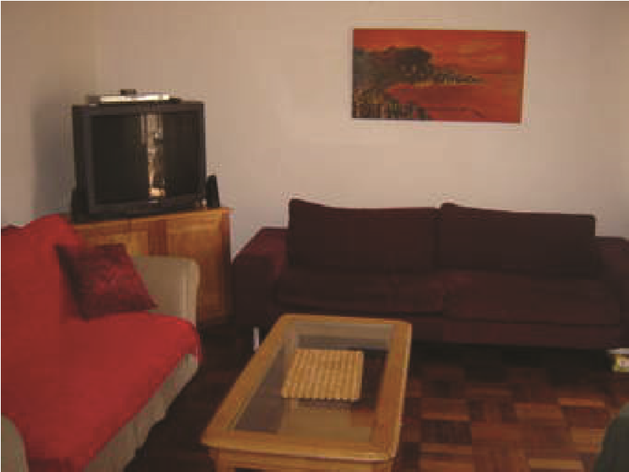
Sebule foyer (waiting room)
Jikoni nayo ni sehemu nyingine muhimu ndani ya nyumba ambapo chakula hupikiwa. Sehemu hii imejengwa kiufundi sana kwa sababu huwa na dohani, ambayo ni tundu linalopitisha moshi. Hata hivyo, sio kila nyumba huwa na jikoni ndani yake. Kuna wale watu ambao jikoni zao huwa nje ya nyumba kuu kwa sababu wao hupika kwa kutumia kuni. Vitu kama vile visu, vijiko, uma, sufuria, sahani, bakuli, sinia na kadhalika hupatikana jikoni.
A kitchen is also another important place inside the house where food is cooked from. This part has been constructed in a very technical way because it be with a chimney, which is a passable vent for smoke. However not every house be with a kitchen inside it. There are those people whereby there kitchen be outside the big house because those ones cook using firewood. Things like knives, spoons, folks, saucepans, plates, bason/ bowl, charger E.T.C they are found in the kitchen.

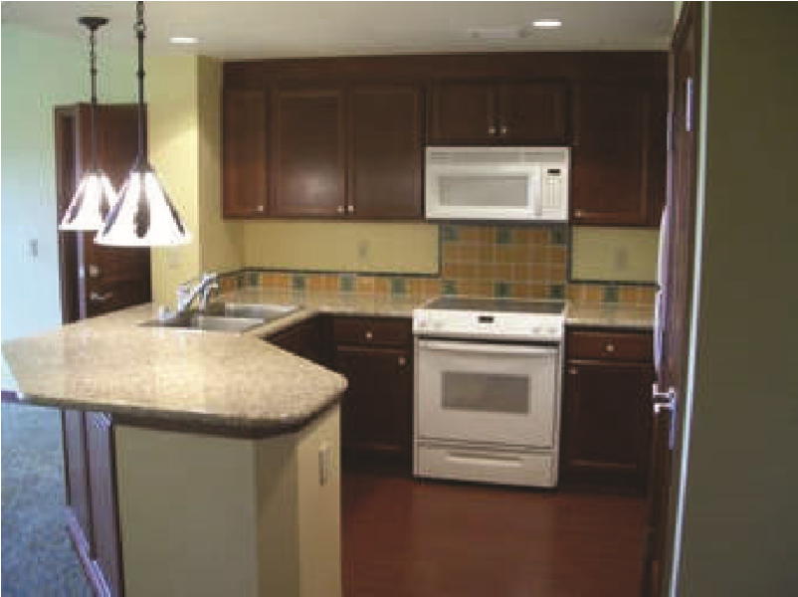
Jikoni ya kisasa (the current kitchen)
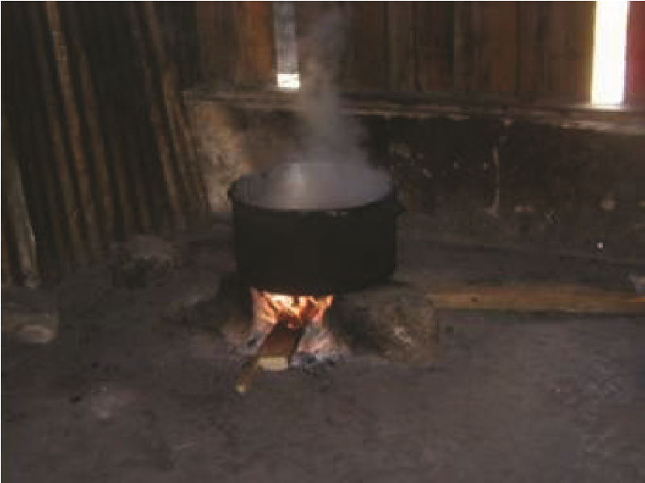
Jikoni la kitamaduni (cultural kitechen)
Choo ni sehemu nyingine muhimu katika nyumba. Kuna choo cha maji ambacho huwa kiko ndani ya nyumba na kile kisicho cha maji ambacho huwa kiko nje. Zaidi ya haya, choo kisichotumia maji, ambacho ni cha kitamadun, kinafaa kiwe ni cha urefu wa mita thelathini kutoka kwa nyumba kuu ili kuepukaa na maradhi yanayoweza kujitokeza kutokana na vimelea vinavyosambazwa na nzi wachafu.
Toilet is also another important part of the house. We have a toilet of water which is found inside the house and that one which is not for water which is found out side. More to that, a toilet which does not use water, it is cultural, it deserve to be in a length of thirty meters away from the main house
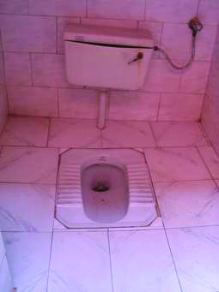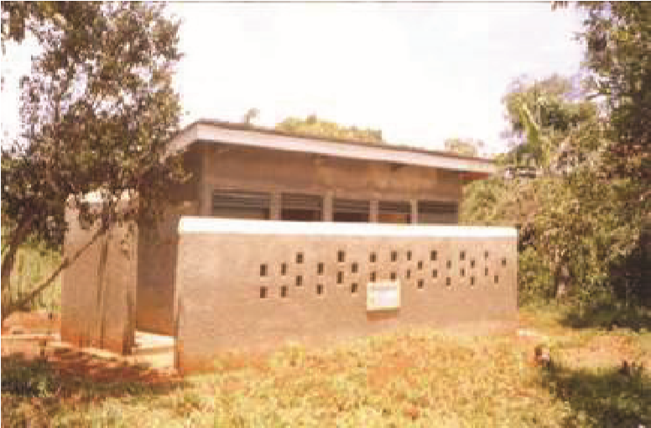
Choo cha maji (toilet of water) Choo kisicho cha maji (toilet which is not of water)
Chumba cha kulala pia hupatikana ndani ya nyumba. Hapa ni mahali ambapo watu hupumzikia baada ya shughuli zao za mchaka kutwa. Katika chumba cha kulala, vitu vinavyopatikana mle ndani ni pamoja na kitanda, shuka, godoro, mto, blanketi na kadhalika.
A room where we sleep also is found inside the house. Here is a place where people rest from after their activities of all day long a year. In a room where we sleep, the things which are found in side are together with a bed, bed sheet, mattress, pilo, blanket and many others.
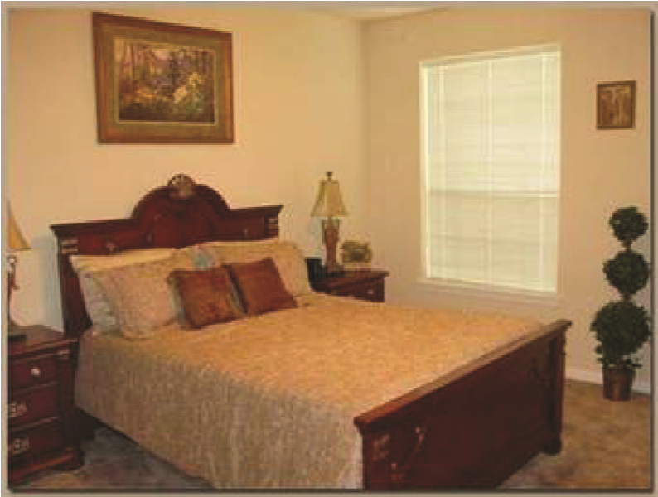
Chumba cha kulala (room where we sleep)
Maswali question
Katika vikundi (in groups)
- Jikoni la kisasa na la kitamaduni, ni lipi unalopenda? Toa sababu.
The current kitchen and the cultural one, which one do you love? Give reasons.
……………………………………………………………………………………………………………………………………………………………………………………………………………………………………………………………………………………………………………………………………………………………………………………………………………………………………………………………………………………………………………………………………………………………………………………………………………………………………………………………………………………………………………………………………………………………………………………………………………………………………………………………………………………………………………………………
- Tazama kwa makini mchoro wa sehemu ya sebule na utaje vitu unavyoona.
Look carefully at the diagram of a part of a foyer (waiting room) and mention things that you are
seeing.
……………………………………………………………………………………………………………………………………………………………………………………………………………………………………………………………………………………………………………………………………………………………………………………………………………………………………………………………………………………………………………………………………………………………………………………………………………………………………………………………………………………………………………………………………………………………………….
- Tumia kamusi kueleza maana ya maneno yaliyokolezwa.
Use a dictionary to explain the meaning of the words which are highlighted
…………………………………………………………………………………………………………………………………………………………………………………………………………………………………………………………………………………………………………………………………………………………………………………………………………………………………………………………………………………………………………………………………………………………………………………………………………………………………………………………………………………………………………………………………………………………………

- Jadiliana kuhusu nomino za ngeli ya u-zi na kuzitaja kwa umoja na wingi.
Discuss about nouns of u-zi class and give them in singular and plural
……………………………………………………………………………………………………………………………………………………………………………………………………………………………………………………………………………………………………………………………………………………………………………………………………………………………………………………………………………………………………………………………………………………………………………………………………………………………………………………………………………………………………………………………………………………………………………………………………………………………………………………………………………………………………………………………………………………………………………………………………………………………………………………………………………………………………………………………………………………………………………………………………………………………………………………………………………………………………………………………………………………………………………………………………………………………………………………………………………………………………………………………………………..

- Shirikiana kutunga sentensi sahihi kwa kuzingatia nomino za ngeli ya u-zi.
Cooperate and form correct sentences by focusing on the nouns of u-zi class.
………………………………………………………………………………………………………………………………………………………………………………………………………………………………………………………………………………………………………………………………………………………………………………………………………………………………………………………………………………………………………………………………………………………………………………………………………………………………………………………………………………………………………………………………………………………………………………………………………………………………………………………………………………………………………………………………………………………………………………………………………………………………………………………………………………………………………………………………………………………………………………………………………………………………………….
Tungeni sentensi ishirini zenye vivumishi viashiria; kumi zikiwa kwa umoja na kumi zikiwa kwa wingi.
Form twenty sentences with adjective indicators, ten in singular and ten in plural
singular form (umoj) ………………………………………………………………………………………………………………………………………………………………………………………………………………………………………………………………………………………………………………………………………………………………………………………………………………………………………………………………………………………………………………………………………………………………………………………………………………………………………………………………………………………………………………………………………………………………………………………………………………………………………………………………………………………………………………………………………………………………………………………………………………………………………………………………………………………………………………………………………………………………………………………………………………………………………………………………………………………………………………………………………………………………………………………………………………………………………………………………………………………………………………………………………………
Plural form (wingi)
…………………………………………………………………………………………………………………………………………………………………………………………………………………………………………………………………………………………………………………………………………………………………………………………………………………………………………………………………………………………………………………………………………………………………………………………………………………………………………………………………………………………………………………………………………………………………………………………………………………………………………………………………………………………………………………………………………………………………………………………………………………………………………………………………………………………………………………………………………………………………………………………………………………………………………………………………………………………………………………………………………………………………………………………………………………………………………………………………………………………………………………………………………….

- Someni sentensi zifuatazo kwa sauti.
Read the following sentences loudly.
Ngeli ya u__ zi (U__ zi class)
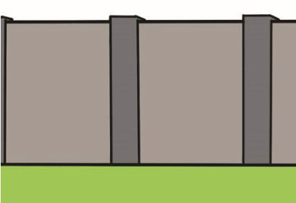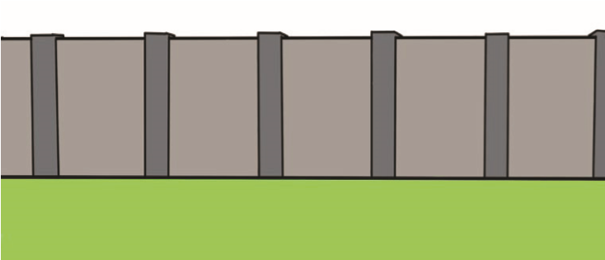
Huu ni ukuta (this is a wall) Hizi ni kuta (these are walls)
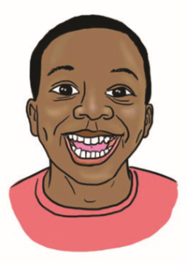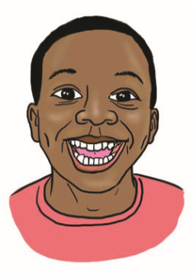
Uso huu ni mzuri (this face is good) Nyuso hizi ni nzuri (these faces are good)
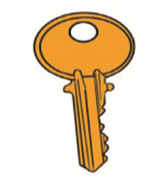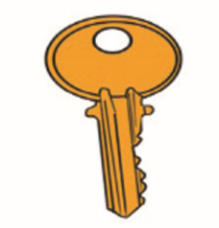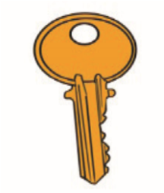
Ufunguo ule si mkubwa (that key is not big) Funguo zile si kubwa (those keys are not big)
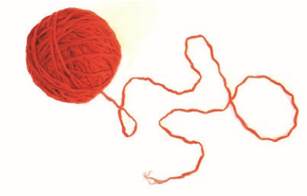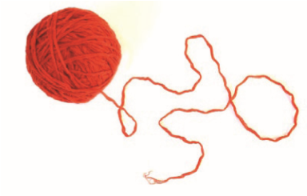
Uzi huu ni wangu (this thread is mine) Nyuzi hizi ni zangu (these threads are mine)
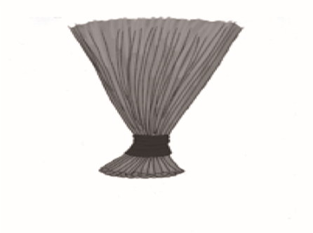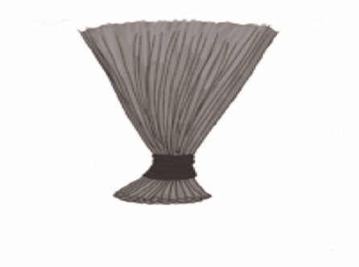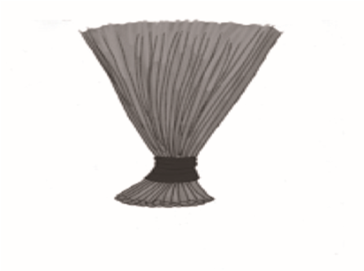

Ufagio ule unapendeza (that broom is lovely) Fagio zile zinapendeza (those brooms are lovely)

Taz: Ngeli hii hujumuisha nomino zinazowakilishwa na U- katika umoja na ZI- katika wingi, kwa mfano,
NB: this class talks about nouns which begin with U- in singular and ZI in plural, forexample,
Umoja (singular) Wingi (plural)
Ukuta umebomoka
The wall has crumbled Kuta zimebomoka
Walls have crumbled
Uzi umekatika
The thread has been broken nyuzi zimekatika
The threads have been broken
Uso unaonekana vizuri Nyuso zinaonekana vizuri
The face looks so nice faces look so nice
Shughuli (activituy)
Katika jozi, ( in groups )
- Igizeni vitendo vya kutoa na kuitikia amri kwa umoja na wingi.
Play practices of giving and react on an order/ command in singular and plural.
…………………………………………………………………………………………………………………………………………………………………………………………………………………………………………………………………………………………………………………………………………………………………………………………………………………………………………………………………………………………………………………………………………………………………………………………………………………………………………………………………………………………………………………………………………………………………………
- Mbadilishane nafasi ili aliyetoa amri kwanza, sasa aitikie amri.
Exchange the capacity so that the one who gave the first order, now react on the
other order
……………………………………………………………………………………………………………………………………………………………………………………………………………………………………………………………………………………………………………………………………………………………………………………………………………………………………………………………………………………………………………………………………………………………………………………………………………………………………………………………………………………………………………………………………………………………………

- Jadiliana juu ya sehemu za nyumba. Baada ya majadiliano, kila kikundi kiandike insha juu ya sehemu za nyumba kikiongozwa na mwalimu. Insha iwe kati ya maneno 150-200
Discuss about parts of a house. After the discussion, every group writes a theme
about parts of a house led by a teacher. The theme be among 150-200 wards.
…………………………………………………………………………………………………………………………………………………………………………………………………………………………………………………………………………………………………………………………………………………………………………………………………………………………………………………………………………………………………………………………………………………………………………………………………………………………………………………………………………………………………………………………………………………………………………………………………………………………………………………………………………………………………………………………………………………………………………………………………………………………………………………………………………………………………………………………………………………………………………………………………………………………………………………………………………………………………………………………………………………………………………………………………………………………………………………………………………………………………………………………………………………………………………………………………………………………………………………………………………………………………………………………………………………………………………………………………………………………………………………………………………………………………………………………………………………………………………………………………………………………………………………………………………………………………………………………………………………………………………………………………………………………………………………………………………………………………………………………………………………………………………………………………………………………………………………………………………………………………………………………………………………………………………………………………………………………………………………………………………………………………………………………………………………………………………………………………………………………………………………………………………………………………………………………………………………………………………………………………………………………………………………………………………………………………………………………………………………………………………………………………………………………………………………………………………………………………………………………………………………………………………………………………………………………………………………………………………………………………………………………..........................................................................

Shughuli Jumlishi
Umemaliza masomo yako na umehitimu na shahada ya kwanza, na sasa umepata kazi. Kwa sababu hiyo, umepata pesa kutoka kwa kazi ambayo unafanya na sasa unataka kujenga nyumba.
You have finished your studies and you have graduated with the first degree, and now you have got a job. Because of that, you have got money from your job you are doing and now you want to construct a house.
- Tambulisha aina ya nyumba ambayo utajenga
Introduce the type of house that you will build
…………………………………………………………………………………………………………………………………………………...................................................................................................................................
- Eleza sehemu za nyumba ambazo nyumba yako itakuwa nazo.
Explain parts of the house which your house will be with.
………………………………………………………………………………………………………………………………………………………………………………………………………………………………………………………………………………………………………………………………………………………………………………………………………………………………………………………………………………………………………………………………………………………………………………………………………………………………………………………………………………………………………………………………………………
- Taja vitu ambavyo utaweka katika nyumba yako
Mention things which you will put in your house.
……………………………………………………………………………………………………………………………………………………………………………………………………………………………………………………………………………………………………………………………………………………………………………………………………………………………………………………………………………………………………………………………………………………………………………………………………………………………………………………………………………………………………………………………………………………………………………………………………………………………………………………………………………………………………………………………………………………………………………………………………………………………………………………………………………………………………………………………………………………
- Igiza jinsi utakavyokuwa unaamrisha wafanyakazi wako ambao watakujengea nyumba.
Tell the manner how you will be commanding your workers who will construct your house
…………………………………………………………………………………………………………………………………………………………………………………………………………………………………………………………………………………………………………………………………………………………………………………………………………………………………………………………………………………………………………………………………………………………………………………………………………………………………………………………………………………………………………………………………………………………………………………………………………………………………………………………………………………………………………………………………………………………………………………………………………..

- Eleza sababu angalau tano kwa nini nyumba ya kisasa ni bora kuliko ya kitamaduni.
Give about five (5) reasons why the current house is better than that one of cultural
house.
………………………………………………………………………………………………………………………………………………………………………………………………………………………………………………………………………………………………………………………………………………………………………………………………………………………………………………………………………………………………………………………………………………………………………………………………………………………………………………………………………………………………………………………………………………………………………………………………………………………………

